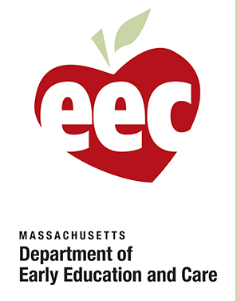

Color one sea creature for each book you read

or each book you watched on our read aloud links.

Return when we open for a learning prize.

This program is offered through the CFCE grant, in collaboration with the Belmont Library’s Children’s Department, Brigham House, and others. This grant is administered by the **Watertown Public Schools**, and funded by a grant from the MA Department of Early Education and Care.

STAY SCHOOL READING LOG