FRIDAY
CONSTRUCTION UNIT
Read Aloud
It’s Not a Box
By: Antoinette Portis
Link to Read Aloud
https://www.youtube.com/watch?v=3KXuBcdmktY

Gross Motor
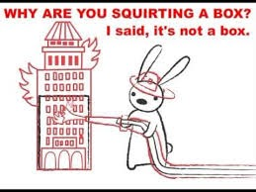
Recycling Challenge

Construct a highrise tower using only recyclables!
What sizes and shapes will you use?
How will you create a door?
Does your highrise building have 4 walls?
How can you create an elevator in your building?
Dramatic Play tip: pretend there is a fire in the highrise and construct a ladder to reach the top!

Song | Fun Activity
Where Are Trucks?  (Tune of “Where is Thumbkin?”)  Where is bulldozer? Where is bulldozer?  Here I am. Here I am.  How are you today, sir? Very well, I thank you.  Drive away. Drive away.  Where is Excavator? Where is Excavator?  Here I am. Here I am.  How are you today, sir? Very well, I thank you.  Drive away. Drive away.  Where is crane? Where is crane?  Here I am. Here I am.  How are you today, sir? Very well, I thank you.  Drive away. Drive away.  Where is backhoe? Where is backhoe?  Here I am. Here I am.  How are you today, sir? Very well, I thank you.  Drive away. Drive away. | IT’S NOT A BOX BUILD  Grab a clean box and help your child plan out what they could make using the box. The box can be what ever you child imagines the box to be. If you open the resource for this activity you can see a list of possible ideas, this is just a list and not a limitation on creativity.  So 3,2,1 Blast off to building. What will you build today?  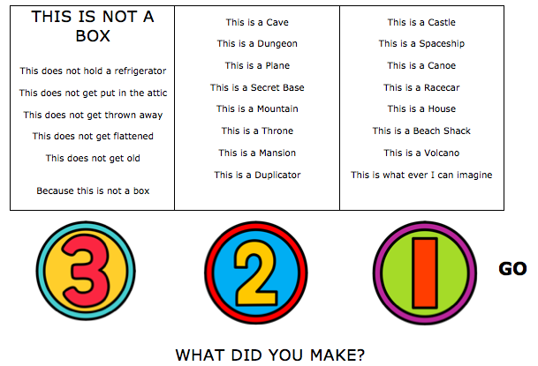

GET MOVING
Get moving inside or
outside in your yard! So get outside, safely, when you can.

