MONDAY
CONSTRUCTION UNIT

Read Aloud
Construction
By : Sally Sutton

Link to Read Aloud
https://www.youtube.com/watch?v=rUL-uiQL2Tk

Gross Motor
Use these ideas to move your body! Put on some music and move!

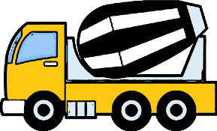
Excavator DIGGING Crane SWINGING
Carpenter SAWING Cement Mixer SPINNING
Bulldozer PUSHING Backhoe SCOOPING
Carpenter HAMMERING Steamroller ROLLING
Raise the ROOF!
Find these Construction Moves cards in the resources section or read them off your phone or tablet.

Song | Fun Activity
Transportation Song  To the tune of “Bumping Up and Down in My Little Red Wagon”  Driving down the road in my little red car,  Driving down the road in my little red car,  Driving down the road in my little red car.  Let’s drive off together!  Racing through the water in my little blue speedboat,  Racing through the water in my little blue speedboat,  Racing through the water in my little blue speedboat,  Let’s race off together!  Flying through the sky in my little white airplane,  Flying through the sky in my little white airplane,  Flying through the sky in my little white airplane.  Let’s fly off together! | Making Shape Art  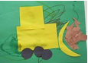  Each day put out shapes and paper and let your child explore building art.  You can precut paper into different shapes. You can use construction paper, newsprint, ads, cereal boxes, anything will work for this project. Then let your children’s imagination and creative take over.  If you have tape, glue, glue sticks, stickers you can use this to hold the shapes in place.

GET MOVING
Get moving inside or
outside in your yard! So get outside, safely, when you can.

