FRIDAY
DINOSAUR UNIT
Read Aloud
How Do Dinosaurs Go to School?
Link to Read Aloud:
https://www.youtube.com/watch?v=aHdpeogRvW8
Link to book read in español:
https://www.youtube.com/watch?v=l6Bh9d9DTb8

Gross Motor
Dinosaur Rowing
Sit on the floor with your big dinosaur feet touching your partner’s
small dinosaur feet!
Hold hands, lean in and lean out, while you sing Row, Row, Row Your Boat, Gently Down the Stream, Merrily, Merrily, Merrily, Merrily, Life is but a Dream!

Song | Fun Activity
Hokey Pokey  You put your right foot in  You take your right foot out  You put your right foot in  And you shake it all about  You do the hokey pokey  And you turn yourself around  That's what it's all about  You put your left foot in  You take your left foot out  You put your left foot in  And you shake it all about  You do the hokey pokey  And you turn yourself around  That's what it's all about  You put your right hand in  You put your left hand in  You put your whole self in | Dinosaur Art  Cut basic shapes from cereal boxes, colored paper, or magazines. Give your child circles, half circles, triangles, and rectangles to arrange and glue into the shape of a dinosaur.  Offer your child cotton balls, shredded paper, string, beans, or pasta for added texture. Scrunch and stick torn pieces of paper to give the dinosaurs scales or lumps.  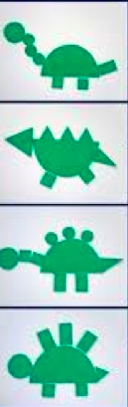

GET MOVING
Get moving inside or
outside in your yard! So get outside, safely, when you can.

