MONDAY
DINOSAUR UNIT
Read Aloud
Dinosaur vs. Bedtime
by Robert Shea

Link to Read Aloud
https://www.youtube.com/watch?v=eJT_oqUL34s

Gross Motor
If you can’t print these out, you can read them from your tablet or screen and still have fun calling out a Dinosaur and a movement.
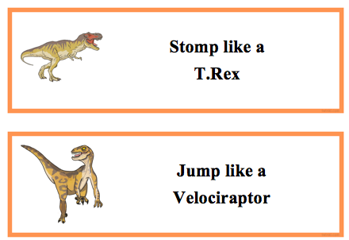
The gross motor cards can be found in the resources section of the unit.

Song | Fun Activity
Dino Song  (tune of I’m a Little Teapot)  I’m a Brontosaurus with four feet.  I eat plants, but don’t eat meat.  Known as Thunder Lizard, that is true.  ‘Cause when I walked, the earth just shook.  Chorus  Dinosaurs, dinosaurs that we know.  Some were large, some were small.  Fossils tell us this is so,  ‘Cause I’ve not seen one after all.  Tyrannosaurus Rex’s my name.  King of the dinosaurs that I am.  I make many run and hide.  ‘Cause I’m mean and like to fight.  I’m Triceratops, with three horns.  A big, big head, and frilly bones.  I’m a fierce fighter, on four feet.  But I eat plants, ’cause they are neat. | Make your own play dough  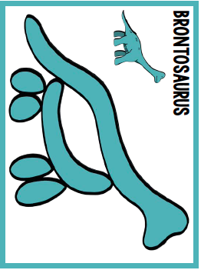  • 1 Cup Water  • 1 Cup Flour  • 1/2 Cup Salt  • 1 Tbsp oil  • Food coloring  • 1 Tbsp Cream of Tartar (not needed, but helps keep it fresher)  Add all ingredients to a pot and stir to combine. Heat pot over medium heat stirring constantly, after about 3-5 minutes the play-dough should start to form into a ball. Remove the pan from heat and place the dough into a large bowl and let cool. I like to knead the dough when cool enough to handle to make sure everything is mixed. Store in an airtight container.  You can print out the play dough sheets for your child to follow, or keep them open in your screen. You can also create dinosaur fossils by imprinting dino’s in the play dough or using pasta.

GET MOVING
Get moving inside or
outside in your yard! So get outside, safely, when you can.

