FRIDAY
BEAR UNIT

Read Aloud
The Little Mouse, Red Ripe Strawberry, and Big Hungry Bear
by Don and Audrey Wood

LINK TO READ ALOUD
https://www.youtube.com/watch?v=apvgbUckC-k

Gross Motor
Teddy Bear Picnic
- Stretch out your body flat on the floor like a picnic blanket.
Reach out your arms and legs to make the biggest blanket that you can!
- Put your teddy bear on your belly, breathe in and watch him rise.
Breathe out and watch him lower down again.
- Sit with your legs criss cross applesauce. Breathe in and smell the
strawberries! Blow out like you’re blowing a bubble.
- Cover your ears with your hands and hum or buzz like a bee!

Song | Fun Activity
Bear Went Over the Mountain  The bear went over the mountain,  The bear went over the mountain,  The bear went over the mountain,  To see what he could see  To see what he could see,  To see what he could see  The other side of the mountain,  The other side of the mountain,  The other side of the mountain,  Was all that he could see  Was all that he could see,  Was all that he could see,  The other side of the mountain,  Was all that he could see! | 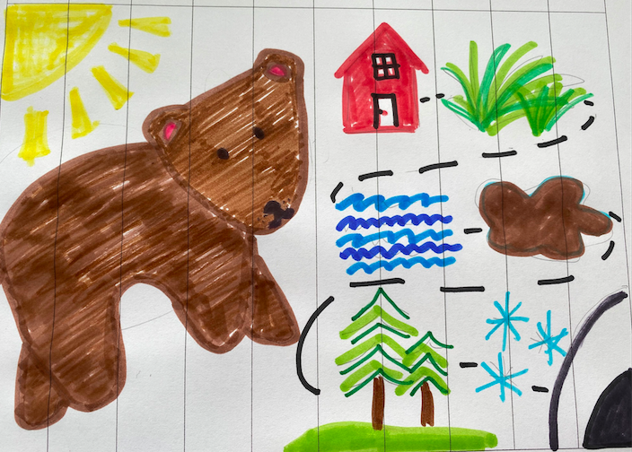  Make a Puzzle Together  Print the Make a Puzzle Sheet in resources. If you can’t print it, you can make it by drawing lines on paper, you can cut a magazine picture into ten parts. Be creative.  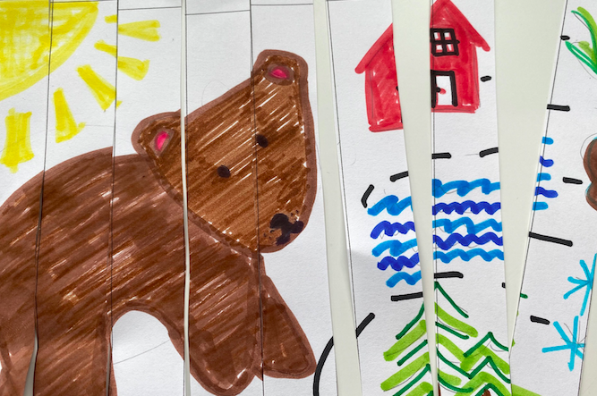  Help your child(ren) draw and color their favorite part of a book from this week. Try to fill the whole box below. Help them cut along the dotted lines to make a puzzle. Try to put it back together in order.

GET MOVING
Get moving inside or
outside in your yard! So get outside, safely, when you can.

