MONDAY
BEAR UNIT

Read Aloud
Brown Bear, Brown Bear, What Do You See?
by Bill Martin, Jr.
LINK TO READ ALOUD
https://www.youtube.com/watch?v=uGfUjJtg2XE&t=12s
LINK TO SING ALONG
https://www.youtube.com/watch?v=9-NlZH_HcOw

Gross Motor
Bear Moves – Sheet in Resource Section

Walk on tiptoes… Climb a tree…
Squirm into your den… Roll in the clover…
Graze for berries… Hop away from the bees…
March like an ant… Fly like a butterfly…
Wiggle Jiggle… Jump!
Give a big bear HUG!

Song | Fun Activity
Teddy Bear, Teddy Bear  Teddy bear, teddy bear  Turn around  Teddy bear, teddy bear  Touch the ground  Teddy bear, teddy bear  Reach up high  Teddy bear, teddy bear  Touch the sky  Teddy bear, teddy bear  Bend down low  Teddy bear, teddy bear  Touch your toes  Teddy bear, teddy bear  Turn out the light  Teddy bear, teddy bear  Say goodnight. | Build A Bear’s Den  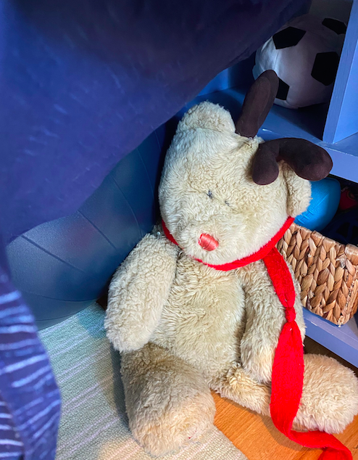  Use blocks, boxes, duplos, pillows, sheets, blankets anything you have around the house. Challenge your kids to build a bear’s den large enough to house six different types of stuffed animals.

GET MOVING
Get moving inside or
outside in your yard! So get outside, safely, when you can.

