MONDAY
TRANSPORTATION UNIT

Read Aloud
Freight Train
By Donald Crews
Link to Read Aloud
https://www.youtube.com/watch?v=0y0cWEKtIl0

Gross Motor
TRANSPORTAION Yoga
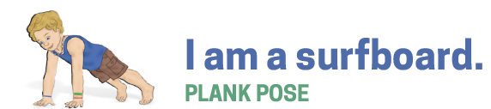
Print out resource or just open on your phone or tablet and try the poses.

Song | Fun Activity
Choo-Choo Train  Sing to Tune of  Jingle Bells  Choo-Choo train, Choo-Choo train,  Chugging down the track  Taking people here and there,  Clickity, clickity, clack!  Chug along, ring the bell  Watch it go, go, go  Chugging, chugging down the track  Here the whistle Blow! | Train Color Sort  You can print the Freight Train Printable on the resource sections or use four pieces of colored construction paper, felt squares, or anything that is Red, Blue, and Yellow & Green. Safely have your children (or you) can cut up recycled flyers, wrapping paper or colored paper in small squares. The younger the child the larger the square.  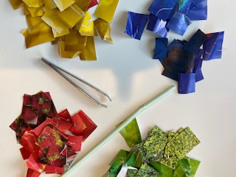  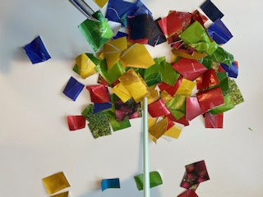  Mix up your colored squares and spread them all over the table. Using fingers (youngest child), tweezers or a straw (Oldest child) to pick up the colored squares and make a pile.  Have your kids pick up one at a time and match to the correct color you call out. You can mxi it up by letting them call out the colors, or switch up how to pick the pieces up.  If you print out the train you will have more color options.  For younger children use less colors. Most important thing is to spend time with your child playing.

GET MOVING
Get moving inside or
outside in your yard! So get outside, safely, when you can.

