FRIDAY
KINDNESS UNIT
Read Aloud
The Kindness Book
by Todd Parr

Link to Read Aloud
https://www.youtube.com/watch?v=wDlNVs2H_3Q

Gross Motor
Parachute Play
Create a Parachute: Use a bed sheet. Get your arms moving and heart rates up by using a sheet to bounce small balls, socks, stuffed animals, or balloons. Wave the parachute up and down, hide under it, toss it in the air, and sing songs

Song | Fun Activity
The More We Get Together  The more we get together, together, together,  The more we get together, the happier we'll be,  ‘Cause your friends are my friends and my friends are your friends.  The more we get together the happier we'll be!  The more we play together, together, together,  The more we play together, the happier we'll be,  ‘Cause your friends are my friends and my friends are your friends.  The more we play together the happier we'll be! | Kindness Boxes  Create a special box for a friend or family member.  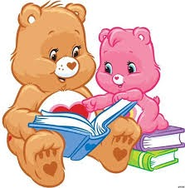  Have fun filling the box with carefully selected items that will make them smile!  Decorate a box and write their name on it.  Include a note saying  how much you love them!  A kindness box I made for my auntie has some strawberries I cut from a store flyer because she loves to eat them!  I also put in some paper hearts and a bookmarker I made to remind her how much I love reading with her!

GET MOVING
Get moving inside or
outside in your yard! So get outside, safely, when you can.

