MONDAY
KINDNESS UNIT

Read Aloud
Be Kind
By Pat Miller
Link to Read Aloud
https://www.youtube.com/watch?v=t6NUJ2JZz50

Gross Motor
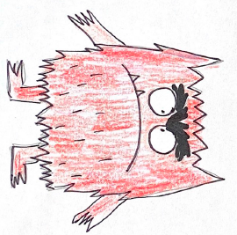
Freeze Dance

Turn on some fun music and dance. When the music stops show a different emotion, such as smiling and jumping up and down or making a mad face and putting your hands on your hips. Pick an Monster Emotion card and act out the emotion for others to guess. If you cannot print use your electronic device and point to one.

Song | Fun Activity
Bucket Fillers  Everyone has a bucket although it is not seen  Everything we do affects it: whether nice or mean  A bucket filler gives, is patient, and is kind  A bucket dipper takes; only keeping himself in mind  We always have a choice to do it right or wrong  The decisions that we make can last very long  I want to make a difference; so I proudly say  That I will be a bucket filler each and every day | Paint Rocks  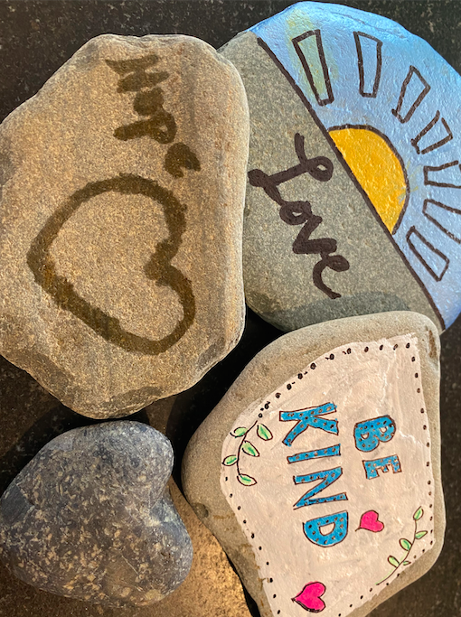  Gather some rocks and wash them down and let them dry. You can then decorate with paint, chalk, or water.  You can them put them in your garden, by your mailbox or any where to send the message of kindness.

GET MOVING
Get moving inside or
outside in your yard! So get outside, safely, when you can.

