MONDAY
FAIRY TALES UNIT
Read Aloud
Each Peach Pear Plum board book
By Allan Ahlberg
Link to Read Aloud
https://www.youtube.com/watch?v=kIAVjQEs5oI

Gross Motor

Shape Jump

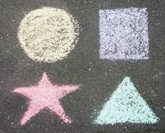
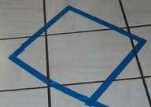
This is a fun way to learn color and shape recognition while still jumping and working on gross motor skills. Draw with chalk shapes out side on your driveway, or painters tape inside, or use cut out cardboard shapes. Put them in any order and have

your child try jumping to the shape.

Song | Fun Activity
Little Red  Once There was a girl,  And her name was Little Red.  She set off to her grandmas’ house,  For Gram was sick in bed.  She wondered through the forest,  With her basket full of bread,  She ran into the Big Bad Wolf,  “Where Are you going?” he said  When Red got to her grandma’s house,  She saw her there in bed,  “oh what big eyes, and ears, and teeth,  You have upon your head!”  “The better to eat you with my dear”,  The hungry wolf just said.  “Please don’t eat me” said Little Red,  “Just eat my bread instead”. | Rapunzel Measure!  Sort By Length  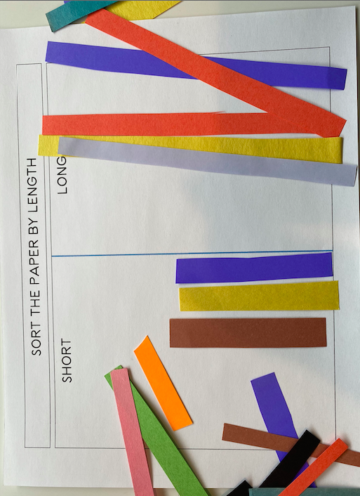  Make papers strips in various colored paper, yarn or ribbon, recycled newsprint works well.  You can print the sort by length sheet from resources or just draw two boxes.  Have your child sort the strips into two piles short or long. Use your handprint or any math manipulative to measure the strips and compare the length (non-standard measurement). Example: The short ones are one child’s handprint and the long are two.

GET MOVING
Get moving inside or
outside in your yard! So get outside, safely, when you can.

