FRIDAY
COLOR UNIT
Read Aloud
Siesta
by Ginger Foglestone Guy
Link to Read Aloud
https://www.youtube.com/watch?v=mR4gAML2oOs

Gross Motor
Build a Tent
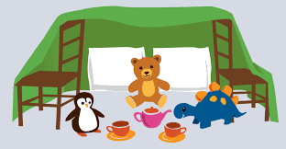
Provide materials for your child to construct a tent-like structure. Pool noodles, long cardboard tubes, lawn chairs, and benches can provide support. Help your child spread a sheet or beach towel over the top. What will you add to your tent? How will you change the tent?

Song | Fun Activity
This is the Way We Go to School  This is the way we go to school,  Go to school, go to school,  This is the way we go to school  So early in the morning!  This is the way we wash our hands,  Wash our hands, wash our hands,  This is the way we wash our hands  So early in the morning!  This is the way we brush our teeth,  Brush our teeth, brush our teeth,  This is the way we brush our teeth  So early in the morning!  This is the way we read our books,  Read our books, read our books,  This is the way we read our books  So early in the morning! | What’s in My Backpack?  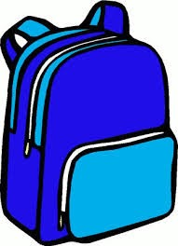  Collect some of your child’s favorite items and add some objects that have interesting textures, such as feathers, scrubbies, foil balls, even soap for added sensory fun.  Place the items into a backpack and zip it up!  Ask your child to partially unzip so they can put their hand inside and feel each of the objects.  Ask questions and help your child describe the object.  Is it hard or soft? Is it smooth or rough? Is it heavy or light?

GET MOVING
Get moving inside or
outside in your yard! So get outside, safely, when you can.

