MONDAY
COLOR UNIT
Read Aloud
Dog’s Colorful Day
by Emma Dodd

Link to Read Aloud
https://www.youtube.com/watch?v=BmnzXC3Dw7o

Gross Motor
Move to the Color

Tape a few shapes on the rug and have your child find a square, triangle or circle. Make more than one of each, and make them big enough for your child to stand in. Don’t have tape, use yarn, string, a belt, rope, be creative.

Song | Fun Activity
The Color Song  Tune: If you’re Happy  and You Know It  If your clothes have any red, any red  If your clothes have any red, any red  If your clothes have any red, put your hand on your head  If your clothes have any red, any red  Repeat but change the color  Blue – Put a finger on your shoe  Brown – Touch your hand to your crown (head)  Black – Touch your hand to your back  Green – Put Your hands on your knees in between | Dog’s Colorful Bones  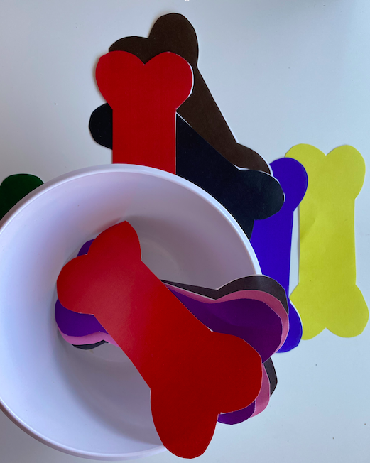  This dog themed activity helps to reinforce color identification and counting for preschoolers, along with storytelling and a bit of pretend play, too. For this activity, you will need:  - The book or use the video link  - Printable Colored Dog Bones from resource section or make your own from recycled cardboard and color them.  - Clean empty pet bowl  - Stuffed dog (optional)  As you read along, invite the children to choose the correct colored bone that matches with the color spot on each page. Have them drop the correct bone into the bowl to give their dog a treat!

GET MOVING
Get moving inside or
outside in your yard! So get outside, safely, when you can.

