FRIDAY
RHYME TIME UNIT
Read Aloud
Maria Had a Little Llama/María Tenía una Llamita
by Angela Dominguez

Link to Read Aloud
https://www.youtube.com/watch?v=6oKxOY0-ywg

Gross Motor
Little Bo Peep Search for Sheep
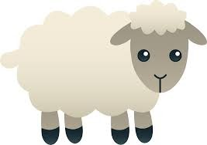
Ask your child to put sheep and other farm animal toys in a basket. Hide the animals and use directional words as your child searches. For preschoolers, draw a simple map of a room and help them to locate the animals by following the map.

Song | Fun Activity
I’m a Little Teapot  I’m a little teapot  short and stout.  Here is my handle, here is my spout.  (Put one hand on your hip.)  (Stick the other arm out to the side)  When I get all steamed up hear me shout,  “Tip me over and pour me out!”  (Lean to the side.)  Soy una pequeña tetera  Soy una pequeña tetera baja y robusta.  Aquí está mi asa, aquí está mi pico.  (Pon una mano en la cadera.)  (Saca el otro brazo hacia un lado)  Cuando me emborrache, escúchame gritar  "¡Inclíname y derrámame!"  (Inclinarse a un lado.) | Mr. Golden Sun Tea Party  Planning a tea party picnic is an “everyday” family math activity!  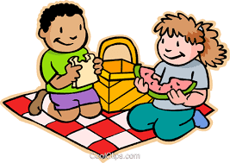  - How many cups do we need?  - Is the blanket big enough for us all to sit on?  - Who are you sitting next to?  - What will we do first?  - Here’s 1 for you and 1 for me!  Make Mr. Golden Sun Tea  with your child by adding tea bags to a clear container of water and placing in a sunny spot. Observe how the water changes as the tea “brews” when the water warms up from the sunlight!

GET MOVING
Get moving inside or
outside in your yard! So get outside, safely, when you can.

