FRIDAY
OCEAN & POND UNIT

Read Aloud
Have You Seen My Duckling?
By Nancy Tafuri

LINK TO READ ALOUD
https://www.youtube.com/watch?v=WRkE81yzIBM

Gross Motor
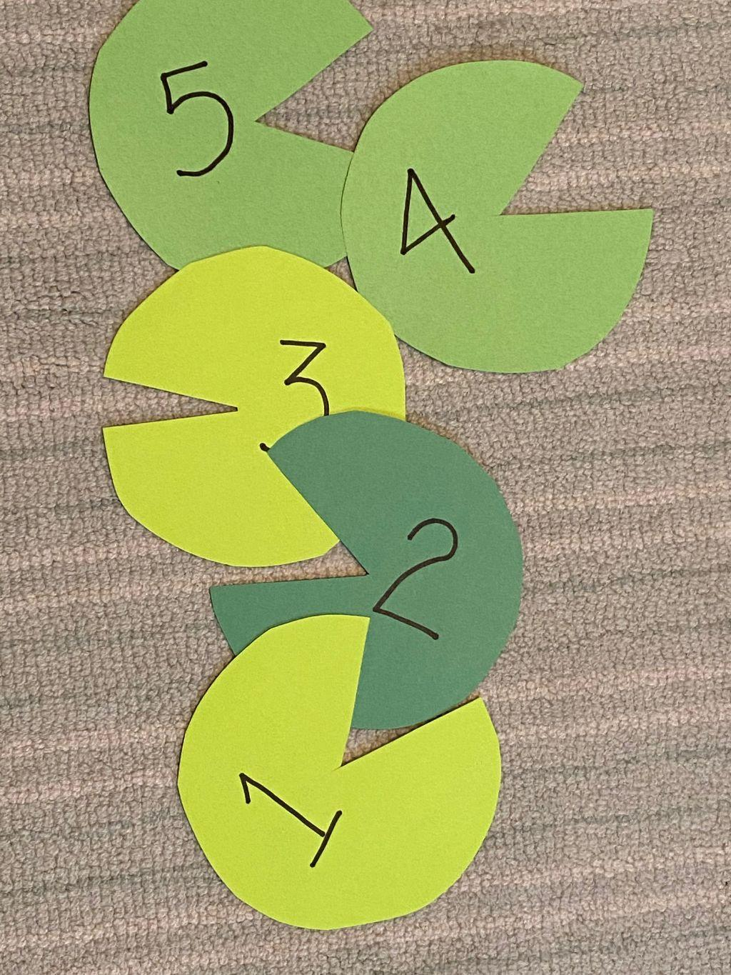
Lily Pad Target Practice
Place your lily pads on the ground, or draw a target with chalk on a sidewalk or in your driveway, or pick a target outside, such as a tree, a garage door, or the side of your apartment building. Encourage your child to throw a beanbag, small ball, rolled up sock at the lily pads or alternative target. Have your child start very close to the target and then move back a few feet, and show them how to throw underhand and overhand.
Be sure to cheer for them when they hit the target.

Song | Fun Activity
Five Green and Speckled Frogs  Five green and speckled frogs sat on a speckled log  Eating some most delicious bugs -- YUM YUM!  One jumped into the pool where it was nice and cool  Then there were four green and speckled frogs.  Repeat with 4, 3, 2, 1, none  Cinco ranas verdes y moteadas  Cinco ranas verdes y moteadas  Estaban sentadas en un tronco moteado  Y comían bichitos sabrosos  Ñam ñam  Repetir con 4,3,2,1,0 | Have You Seen My Duckling?  Lost and Found game  - Take turns hiding a duck or other stuffed animal.  - Give clues about where others can find the lost duck.  - Make sure to guide them when they are close to it by saying “hot” or far from it by saying “cold”  - The one who finds the duck takes the next turn to hide it!

GET MOVING
Get moving inside or
Outside in your yard So get outside, safely, when you can.

