MONDAY
OCEAN & POND UNIT

Read Aloud
Jump Frog Jump
by Robert Kalan & Byron Barton

LINK TO READ ALOUD
https://www.youtube.com/watch?v=SrgL5ac0i-w

Gross Motor
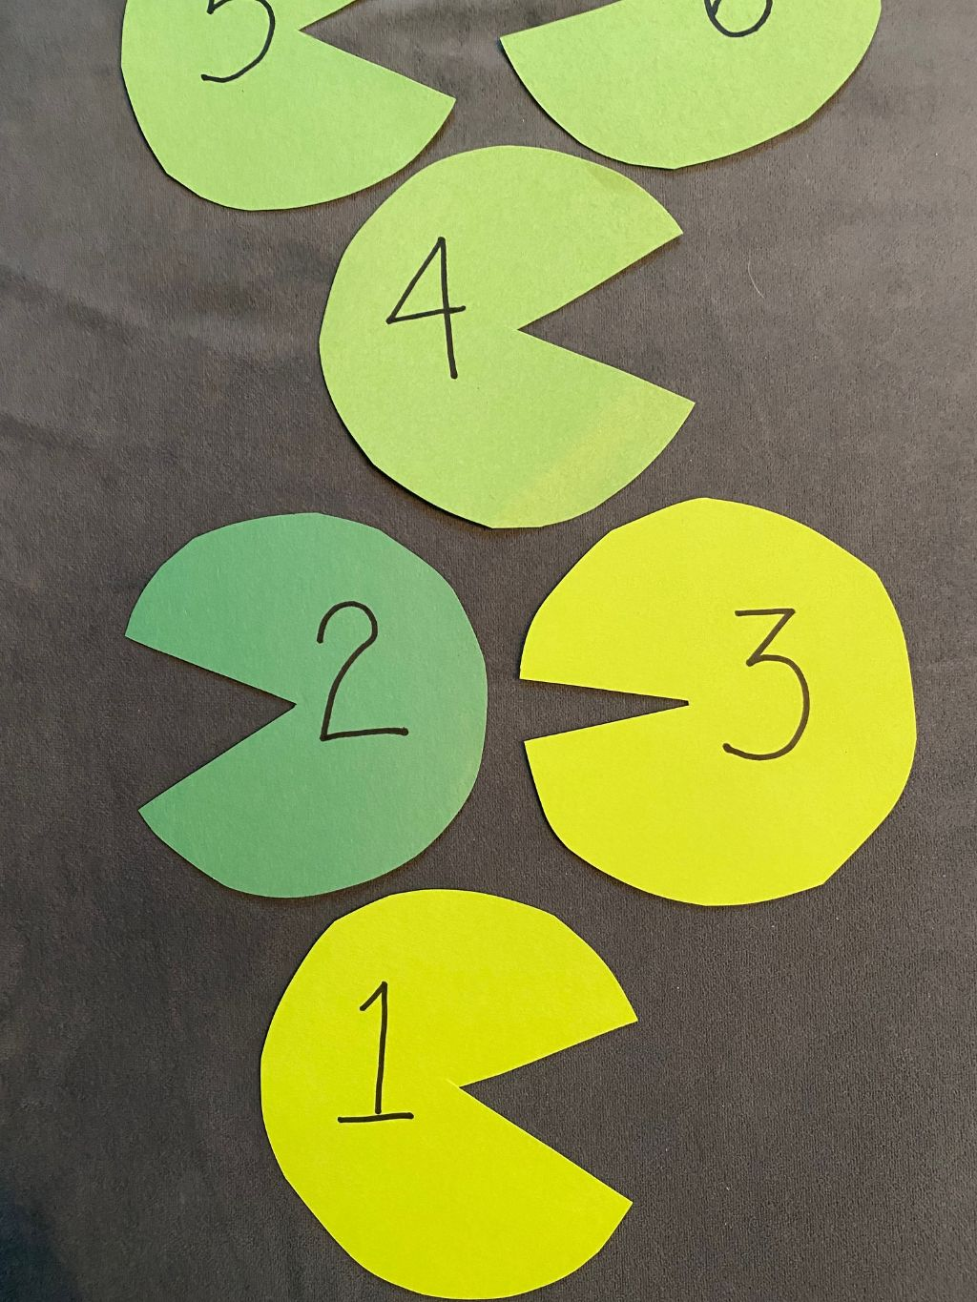
Lily Pad Jump Hopscotch
Make 10 lily pads out of green paper, newsprint, face cloths, socks or whatever you have around the house. If you can make them with paper, number them 1-10. Place them in order 1-10 or next to each other.
Have your child hop up and back to 10. All hopping is done on one foot unless your child needs to hop with two feet and then put two lily pads side-by-side. Call out numbers and have your child hop to them.
(Hold onto Lily Pads to use on Wednesday and Friday)

Song | Fun Activity
Five Green and Speckled Frogs  Five green and speckled frogs sat on a speckled log  Eating some most delicious bugs -- YUM YUM!  One jumped into the pool where it was nice and cool  Then there were four green and speckled frogs.  Repeat with 4, 3, 2, 1, none  You can print the frogs here:  https://picklebums.com/five-green-frogs-printable/ | Create a POND  sensory bowl  Gather materials to use:  Large shallow bowl,  sticks, stones, sand, water, dirt, leaves, fabric  What will float on the surface as a lily pad? (try leaves!)  Create frogs: draw eyes, nose, mouth on a plastic lid  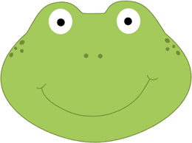  Create bugs: use rice, cereal, beans for frogs to eat

GET MOVING
Get moving inside or
Outside in your yard So get outside, safely, when you can.

