THURSDAY
OCEAN & POND UNIT

Read Aloud
Rainbow Fish
By Marcus Pfister

LINK TO READ ALOUD
https://www.youtube.com/watch?v=r9mryuEKkKc

Gross Motor
Beach Themed Gross Motor

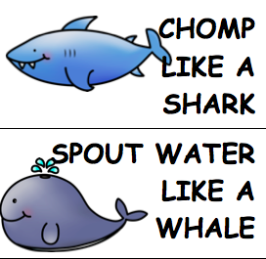
If you can’t print these out, you can read them from your tablet or screen and still have fun calling out a sea creature and a movement. The gross motor cards can be found in the resources section of the unit.

Song | Fun Activity
1, 2, 3, 4, 5, Once I Caught a Fish Alive  One, Two, Three, Four, Five,  Once I caught a fish alive,  Six, Seven, Eight, Nine, Ten,  Then I threw him back again.  Why did you let him go?  Because he bit my finger so.  Which finger did he bite?  This little finger on my right.  Don’t know the song, you can listen to it here.  https://www.youtube.com/watch?v=9ir_l7qTiZ4 | Ocean Creatures line tracing  Use your finger or crayon to trace ocean creatures moving through the ocean!  Find this in the resources section.  Color a RAINBOW fish and send it to a friend!

GET MOVING
Get moving inside or
Outside in your yard So get outside, safely, when you can.

