TUESDAY
OCEAN & POND UNIT

Read Aloud
Commotion in the Ocean
by Giles Andreae

LINK TO READ ALOUD
https://www.youtube.com/watch?v=9pRhgZ8Jffs

Gross Motor
Beach Themed Gross Motor

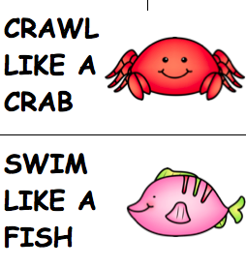
If you can’t print these out, you can read them from your tablet or screen and still have fun calling out a sea creature and a movement. The gross motor cards can be found in the resources section of the unit.

Song | Fun Activity
1, 2, 3, 4, 5, Once I Caught a Fish Alive  One, Two, Three, Four, Five,  Once I caught a fish alive,  Six, Seven, Eight, Nine, Ten,  Then I threw him back again.  Why did you let him go?  Because he bit my finger so.  Which finger did he bite?  This little finger on my right.  Don’t know the song, you can listen to it here.  https://www.youtube.com/watch?v=9ir_l7qTiZ4 | Create your own Bubbles  - Put ½ cup of liquid dish soap into a bowl  - Add 1 ½ cups of water  - Add 2 spoons of sugar  - Stir ingredients gently.  - Poke a hole in a small cup to blow through.  - Dip the big end of the cup in the bubble mix and blow!

GET MOVING
Get moving inside or
Outside in your yard So get outside, safely, when you can.

