FRIDAY
THINGS THAT GROW UNIT

Read Aloud
The Very Hungry Caterpillar
by Eric Carle

Link to Read Aloud
https://www.youtube.com/watch?v=vkYmvxP0AJI

Gross Motor
Garden Gross Motor Cards
If you can’t print these out, you can read them from your tablet or screen and still have fun calling out a sea creature and a movement. The gross motor cards can be found in the resources section of the unit.

Song | Fun Activity
Itzi, bitzi araña (Spanish)  Itzi, bitzi araña,  tejió su telaraña.  Vino la lluvia,  y se la llevó.  Salió el sol,  se secó la lluvia.  Y Itzi, bitzi araña,  otra vez subió.  The Itsy Bitsy Spider  went Up the water spout,  down came the rain,  and washed the spider out.  Out came the sun  and dried up all the rain.  And the itsy bitsy spider  went up the spout again. | Create a Caterpillar  Use an egg carton to create a caterpillar by cutting (or ripping) the carton in half lengthwise.  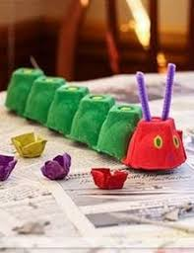  Use markers, paints, or crayons to color the caterpillar. Add antennae made from yarn or twist ties stuck in one end.  Tell the story with the fruits and vegetables you have. They might be different from those in the book!  Don’t forget to feed the caterpillar a leaf when he has a stomachache!

GET MOVING
Get moving inside or
outside in your yard! So get outside, safely, when you can.

