MONDAY
THINGS THAT GROW UNIT

Read Aloud
Planting a Rainbow
by Lois Ehlert

Link to Read Aloud
https://www.youtube.com/watch?v=sti3PXBeVag

Gross Motor
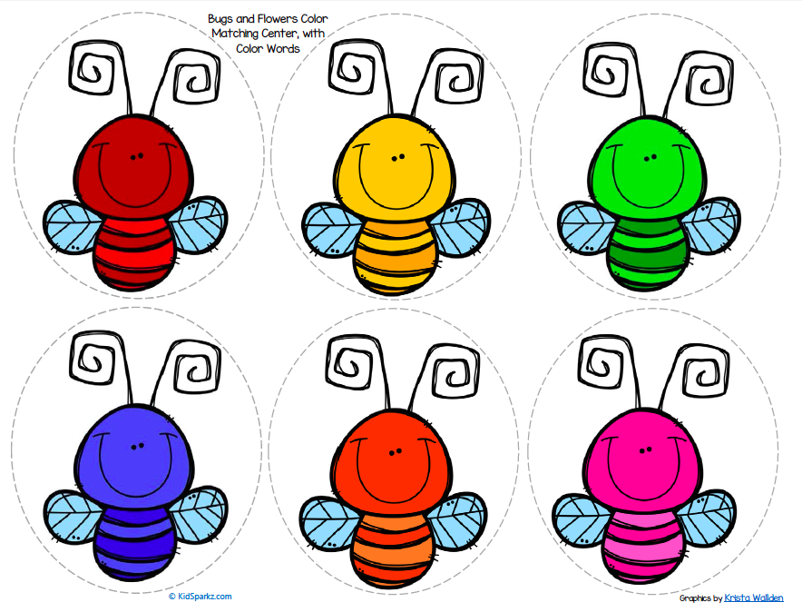
Color Matching Game

Print out the Color Matching Game (in resource section) put the six colored bees in different spots around the room. If you can’t print, you can use different colored socks, towels, scrap paper instead. You can also play this on your phone or screen and flip back and forth between the colors and finding something in your house that color. Call out one color at a time and buzz on over to it.
Most important thing is to spend time with your child playing.

Song | Fun Activity
Mr. Sun  Oh, Mr. Sun, Sun, Mr. Golden Sun  Please shine down on me  Oh, Mr. Sun, Sun, Mr. Golden Sun  Hiding behind a tree  These little children are asking you  To please come out so we can play with you  Oh, Mr. Sun, Sun, Mr. Golden Sun  Please shine down on me | Color in Nature  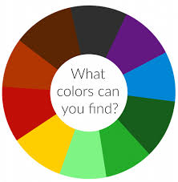  Take a walk outside and collect objects in nature to match this color wheel. You can also color your own wheel for the objects you find. A blank wheel is found in the resources section.

GET MOVING
Get moving inside or
outside in your yard! So get outside, safely, when you can.

