FRIDAY
ZOO UNIT

Read Aloud
Zoo-looking
by Mem Fox
Link to Read Aloud
https://www.youtube.com/watch?v=oaOAPbvg17o

Gross Motor
Animal Dance Party
Boogie like Gerald the giraffe to your favorite tunes!
Add your own rhythms and moves.
Try skipping, prancing, shuffling, swaying, swishing, and twirling.
Hold hands while you do the tango!
Finish with a cha-cha-cha!
And take a bow!

Song | Fun Activity
If You’re Happy and You Know It!  If you’re happy and you know it,  ROAR out loud!  If you’re happy and you know it,  ROAR out loud!  If you’re happy and you know it, and you really want to show it,  If you’re happy and you know it,  ROAR out loud!  (like a lion)  If you’re happy and you know it,  WAVE your arms!  (like a monkey)  If you’re happy and you know it,  SPIN around!  (like a lemur)  If you’re happy and you know it,  NOD your head!  (like a giraffe) | Snake Art  Collect a variety of recycled paper towel roll, scrape paper or a sock for this activity.  Paper Towel Roll: You can cut the paper towel into pieces or in a spiral pattern to make the body of the snake. Then let your children decorate with paint, markers, crayons, tape, or pencils.  Scrape Paper: Have your child cut strips of paper about 8” by 2” and make a paper chain snake. Connect loops with tape or staples.  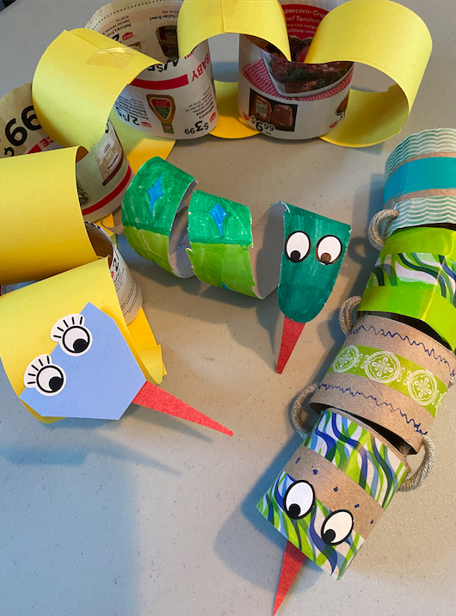  Sock: Grab a stripped sock and stuff with another sock to make the base of the snake. Then make a head out of paper and attach.

GET MOVING
Get moving inside or
outside in your yard! So get outside, safely, when you can.

