MONDAY
ZOO UNIT
Read Aloud
Good night, Gorilla
By Peggy Rathmann

Link to Read Aloud
https://www.youtube.com/watch?v=1Kl8S61bCn4

Gross Motor
TIP TOE GAME
She also enjoyed the challenge of walking on tiptoes. It takes certain muscles to do so, and it was a good action. She loves to dance, and I think practicing walking on tiptoes gives children muscles exercise. Unlike normal “dancing,” this was controlled. The idea was to be quiet and not bother the zookeeper!

Song | Fun Activity
Do you know the Zoo Keeper  (tune of "The Muffin Man")  Do you know the Zoo Keeper,  the zoo Keeper,  the zoo Keeper?  Do you know the zoo keeper  He likes the animals?  Oh, he loves the letter Z,  the letter Z,  the letter Z,  Oh, he loves the letter Z  and likes the animals. | ANIMAL ESCAPE  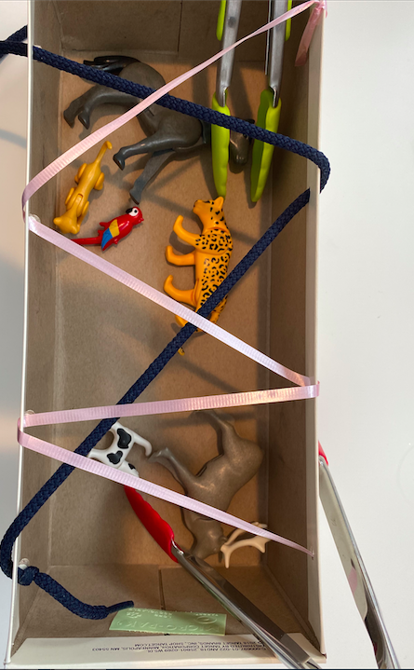  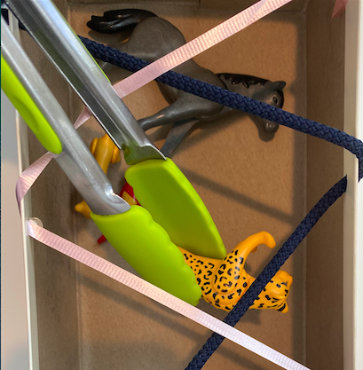  The point of the activity is to let your child problem solve and figure out a way to free the zoo animals from a string-filled box/basket. You can use a recycled box, a colander, hamper, or basket anything that you can loop string through. The string can be a shoe-lace, ribbon, yarn, or scraps of fabric. Easy, use less string and large items; harder use more string and smaller items. What should you do if you don’t have animals in the house you can use rolled up socks, crumpled paper, or cut up paper towel rolls.

GET MOVING
Get moving inside or
outside in your yard! So get outside, safely, when you can.

