FRIDAY
TRANSPORTATION UNIT
Read Aloud
Duck on a Bike
by David Shannon
Link to Read Aloud
https://www.youtube.com/watch?v=pmAzhohAeIs
Read in Español
https://www.youtube.com/watch?v=P2x8UXXjJCU

Gross Motor
Follow the Leader
Play this game by taking turns as the leader who chooses which animal from the story you will be as you follow along behind. Invite the family to join in!

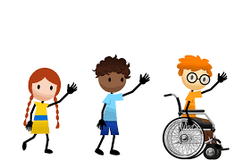
Move like a DUCK, a COW, a SHEEP, a DOG, a CAT, a HORSE, a CHICKEN, a GOAT, a PIG, and a MOUSE!

Song | Fun Activity
This is the Way We...  This is the way we ride our bike,  ride our bike, ride our bike.  This is the way we ride our bike,  so early in the morning.  This is the way we drive the tractor,  drive the tractor, drive the tractor.  This is the way we drive the tractor,  so early in the morning.  This is the way we ride the bus,  ride the bus, ride the bus.  This is the way we ride the bus,  so early in the morning.  This is the way we fly the plane,  fly the plane, fly the plane.  This is the way we fly the plane,  so early in the morning. | Ramps: Roll or Slide?  Help your child to create a ramp with a long piece of cardboard or wood. Use books or chairs under the ramp to prop it up.  Test small objects to determine if they roll or slide on the ramp.  - toy cars  - markers  - glue sticks  - balls  - blocks  - bottle tops  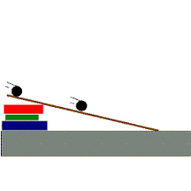  - small boxes  - round lids  What do you notice about the things that roll? Can an item both roll and slide depending on how you turn it?

GET MOVING
Get moving inside or
outside in your yard! So get outside, safely, when you can.

