FRIDAY
RAINFOREST UNIT
Read Aloud
“Slowly, Slowly, Slowly,” Said the Sloth
by Eric Carle

Link to Read Aloud
https://www.youtube.com/watch?v=lZX39Nc20Ys

Gross Motor
Opposites Game
Your child will learn about opposites when playing this game. When your child reaches up high, you reach down low! When your child walks forward, you walk backwards! When your child holds a ball in their right hand, you hold a ball in your left hand! When your child stands up, you sit down! Have fun!

Song | Fun Activity
Two Little Toucans  Two little toucans,  sitting on a hill,  One named Jack,  and one named Jill.  Fly away, Jack! Fly away, Jill!  Come back, Jack! Come back, Jill!  Two little toucans,  flying in the sky,  One named Low,  and one named High.  Fly away, Low! Fly away, High!  Come back, Low! Come back, High!  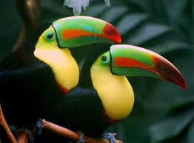 | Bubble Snake  Gather your materials:  ؄ bottle  ؄ scissors  ؄ elastic band  ؄ washcloth or  sock  - Cut off bottom of the bottle  - Cut a circle from the washcloth or toe of the sock  - Cover the cut end of the bottle with the washcloth circle or sock and secure with an elastic band  - Dip in bubble mix and blow to create a bubble snake!  Bubble Mix recipe:  Add ½ cup of liquid dish detergent to a bowl with 1½ cups of water and 2 spoons of sugar. Mix!

GET MOVING
Get moving inside or
outside in your yard! So get outside, safely, when you can.

