MONDAY
RAINFOREST UNIT

Read Aloud
Over in the Jungle
By Marianne Berkes
Link to Read Aloud https://www.youtube.com/watch?v=eSazraM-7wY

Gross Motor
Rain Forest Themed Gross Motor
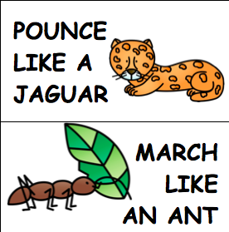
If you can’t print these out, you can read them from your tablet or screen and still have fun calling out a sea creature and a movement. The gross motor cards can be found in the resources section of the unit.

Song | Fun Activity
Walking In The Jungle  Tune: Going on a Bear Hunt  Walking in the jungle. Walking in the jungle. We're not afraid. We're not afraid.  Walking in the jungle. Walking in the jungle. We're not afraid. We're not afraid.  One step. Two steps. Three steps forward. One step. Two steps. Three steps back. Stop. Listen. What’s that? It's a frog! We're not afraid!  Stomping in the jungle. Stomping in the jungle. We're not afraid. We're not afraid.  Stomping in the jungle. Stomping in the jungle. We're not afraid. We're not afraid.  One step. Two steps. Three steps forward. One step. Two steps. Three steps back. Stop. Listen. What’s that? It's a monkey! We're not afraid!  Skipping in the jungle. Skipping in the jungle. We're not afraid. We're not afraid.  Skipping in the jungle. Skipping in the jungle. We're not afraid. We're not afraid.  One step. Two steps. Three steps forward. One step. Two steps. Three steps back. Stop. Listen. What’s that? It's a Tiger! We're not afraid! | Make a Rain Stick  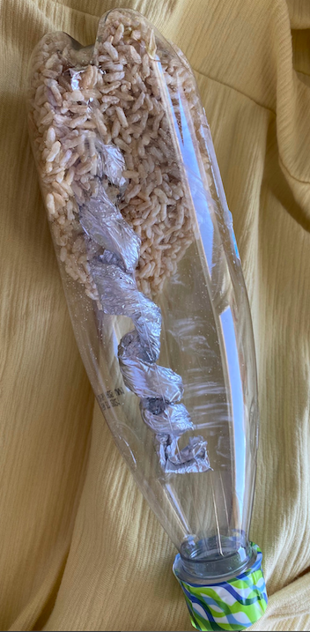  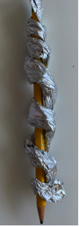  Go to the recycling bin and grab an empty and dried out water bottle or other plastic container with lid. Take a piece of tin foil and roll it around a pencil to make a spiral. Insert into plastic bottle; add dried rice, sand, rocks, popcorn, dried beans, what ever you have in or around your house that will move inside the bottle. Seal top of the bottle with glue and tape.  Have fun making music.

GET MOVING
Get moving inside or
outside in your yard! So get outside, safely, when you can.

