STEAM WIND & WATER

Read Aloud
One Dark Night
Book by Hazel Hutchins

Link to Read Aloud: https://www.youtube.com/embed/C5YLI1soeZw
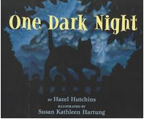

STEM VIDEO
STEM CHALLENGE: Can you build a shelter for animals in stormy weather?
SONG: Five Little Ducks Went Out To Play
FINE MOTOR: Q-Tip Starry Night Painting
Creating a summer countdown calendar
OTHER: Make a Pet Cloud
How to use scissors safely
GROSS MOTOR: Get moving inside or outside in your yard! So get outside, safely, when you can

LESSON 3.3
Teaching Procedure:

Why and/or how question:
Why do animals need shelter from stormy weather?
Brainstorming
Give students time to explore the materials so they can imagine what to do with them.
Planning
Discuss and collaborate how to make a shelter to protect animals from stormy weather.
Producing
Build the shelter. Test with spray bottle of water or cup of water.
Problem solving
Discuss how can you improve your shelter
Provide more time to students to adjust their structure if it is not waterproof
Evaluation
Was your shelter waterproof and protective?
How could you improve your shelter?
Prompting Thought Processes (Asks students to explain thinking)

Ask students their ideas on why they built their shelter the way that they did.
Then have students record their shelter on the recording sheet named “Draw a picture of your shelter.”

One Dark Night

STEAM Challenge:
Can you build a shelter for animals in stormy weather?

Book:  One Dark Night  Objective:  To build a shelter to protect animals in stormy weather  Materials:  - ‘animal’ toy manipulative; preferably a cat  - glue  - scissors  - Building materials: such as recyclable materials (cardboard, string, paper).  - waterproof material (ex., aluminum foil, plastic wrap)  - spray bottle with water or cup  - Recording sheet for each child (Draw your plan for the shelter) | PreK standard:  ESS2-6  Provide examples of the impact of weather on living things.  -make connections between the weather and what they wear and can do and the weather and needs of plants and animals for water and shelter  Importance  - Building teaches kids early math and engineering skills through hands-on learning.  - Improves fine motor skills.  - Enhances logical thinking capability-it provides mental stimulation and teaches children cause and effect
Draw your shelter LESSON 3.3

COUNTING STARS
You can cut them out and glue them to a Popsicle stick,
a real stick, a cut piece of cardboard to make puppets.
This way your child can act out the song as you both sing it.
Song Lyrics:
Counting Stars
One little star came out tonight,
It twinkled and twinkled with all of its might.
Two little stars came out tonight,
They twinkled and twinkled with all of their might.
Continue with: three, four & five little stars.
End with the children all holding up their hands and wiggling them.
Thousands of stars came out tonight, Twinkling, and twinkling a beautiful sight!

Q-Tip Starry Night Painting
Make a starry night.
- Using white or yellow paint dab the stars until they are filled.
- You can also use the extra paint to just paint the stars in the night sky.

Q-Tip Starry Night Painting

Make a starry night.
- Using white paint dab the stars until they are filled.
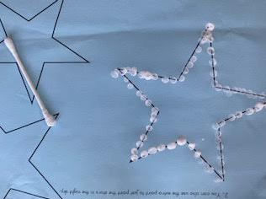
- You can also use the extra paint to just paint the stars in the night sky.

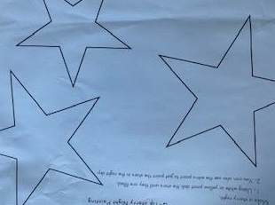

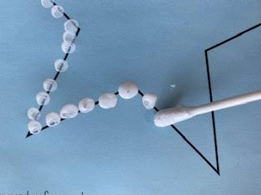

CREATING A SUMMER COUNTDOWN CALENDER

Please supervise and review the instructions for proper scissors usage.
Scissors are sharp tools.

Cutting skills take time for children to develop. Being able to use scissors to cut well is important for many preschool and school activities including art and craft. Children may have the skills to use small scissors by three to four years of age, but scissor skills are not fully developed until 6 years of age.
We use visual aids to assist children in understanding words or events. Young children can understand the concepts of before and after, but not the days of the week. This is why this is a fun way to countdown your days. You can add specially events into the paper chain calendar, like the fourth of July or birthdays.

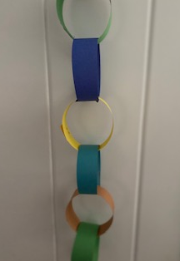
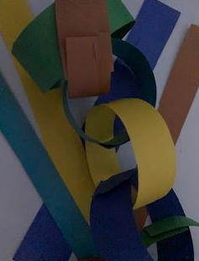
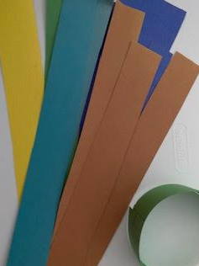

INSTRUCTIONS FOR SCISSOR USAGE

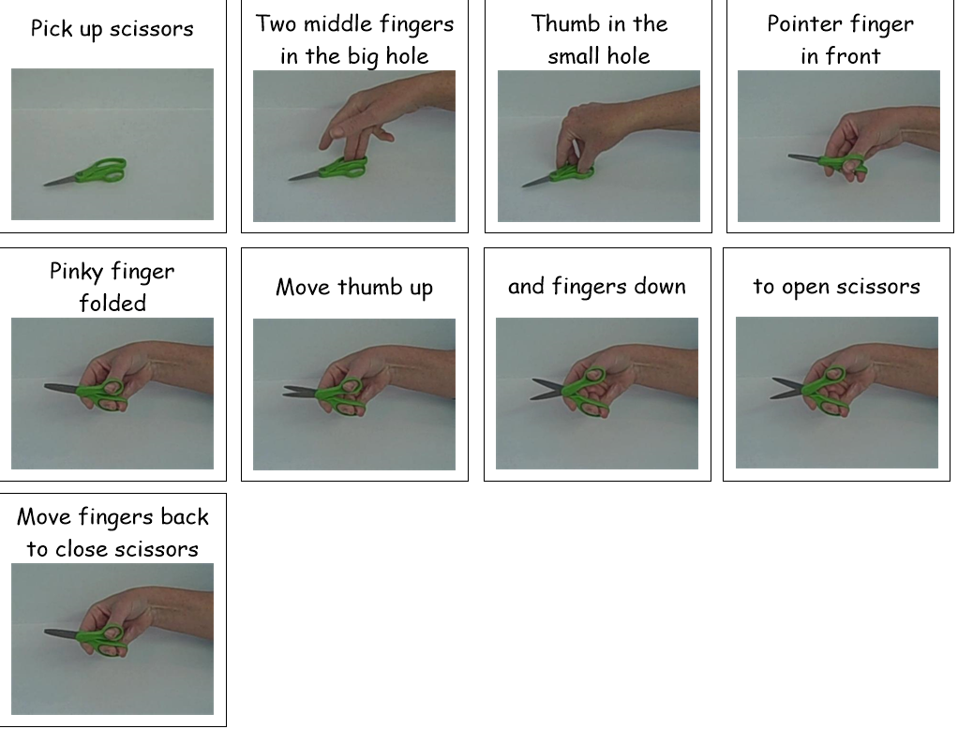
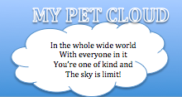
Make A Pet Cloud

Materials
• Cotton Ball
• Eyes
• Plastic Bag
For inspiration we looked at the clouds in the sky.
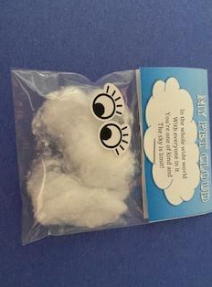
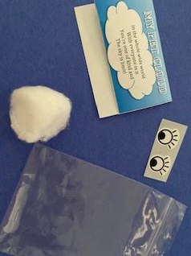
Toddlers and preschoolers are able to work on fine motor skills. Have them stretch the cotton ball into the shape they like. Put it into the bag and them have them attach the eyes. An adult can staple the card to the bag.
When they are done they will have made their very own pet cloud.

