**STEAM World of Color**

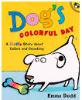

|  |
| --- |
| **Read Aloud** |
| Dog’s Colorful Day  Book by Emma Dodd  Link to Read Aloud :  <https://www.youtube.com/embed/juE7WbDDF3c> |

|  |
| --- |
| **STEM VIDEO** |
| STEM CHALLENGE: Can you use your sense of touch to identify an item without seeing it?    SONG: The Color Song  FINE MOTOR**:** Dogs Colorful Day Retell of Story  OTHER: Color Hunt  GROSS MOTOR: Get moving inside or outside in your yard! So go outside, safely, when you can  STORY WALK   * Gore Place has partnered with the Coordinated Family and Community Engagement (CFCE)  grant-funded program administered by the Watertown public schools to re-introduce the Story Trail back to the property! * Directions: Gore Place is located at 52 Gore Street in Waltham, Massachusetts just off Route 20. From I-90 (Mass Pike) take exit 17 to Watertown Square. Turn left onto Route 20 (Main Street). Travel 1~1/4 miles to Gore Street. |

LESSON 4.2

**Teaching Procedure:**

Why and/or how question:

Using only your hands (your sense of touch) can you guess/predict what object is in the feely box?

Brainstorming

Planning

Discuss with the group some descriptive words that can be used when feeling items. Some examples of descriptive words to use are soft, hard, smooth, rough, and squishy.

Producing

Put one item into the feely box.

Invite a student to touch the item, describe what they feel and guess what the item is.

Problem solving

Was the item what you thought it was? Why did you think it was “x”?

Evaluation

Have students draw one item from the feely box and help them write the description of how it felt. OR a sorting activity using the visuals of the items in the feely box (such as smooth/rough or soft/hard)

Prompting Thought Processes (Asks students to explain thinking)

Before removing the item from the feely box, have the child explain how they decided to guess which items it was in the box.

*Dog’s Colorful Day*

|  |  |
| --- | --- |
| Book:  Dog’s Colorful Day  Objective:  Have the students describe what they feel, make a prediction and see if their prediction matches the object.  Materials:   * A feely box with 2 end holes, we suggest a tissue box. * Objects with various textures (hard, soft, squishy, smooth, rough). Some examples could include a small ball of playdough, some paint in a ziploc bag, a small ball, a piece of sandpaper, a cotton ball, a crumpled piece of paper, a wet sponge * Visuals of each item   **should visuals of items be created to help narrow down choices or should items just be previewed?  If visuals, maybe the evaluation could be to glue the picture of the item into the correct column – cotton ball in the soft column? | PreK standard:  LS1-3  Use their five senses in their exploration and play to gather information.  Importance   * A feely box for exploring touch is a great tool for encouraging thinking skills including perception, prediction, analysis and synthesis.  This activity will also help children develop expressive language skills by developing their descriptive language. * Our sense of touch helps us learn about our world by feeling and learning the size, texture, and shape of things. You can feel with the skin all over your body. We can tell the difference between hard and soft, smooth and rough, hot and cold, wet and dry, and feel pain because of our sense of touch. |

**STEAM Challenge:**

Can you use your sense of touch to identify an item

without seeing it?

**DRAW A PICTURE OF YOUR ITEM** LESSON 4.2

Opposites

SMOOTH or ROUGH

DRY or WET

SOFT or HARD

**The Color Song**

Tune: If you’re Happy and You Know It

If your clothes have any red, any red

If your clothes have any red, any red

If your clothes have any red, put your hand on your head

If your clothes have any red, any red



Repeat but change the color

Blue – Put a finger on your shoe

Brown – Touch your hand to your crown (head)

Black – Touch your hand to your back

Green – Put Your hands on your knees in between

**Dogs Colorful Day Retell of Story**

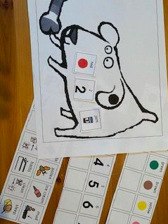This book is about an adorable puppy who adds one colorful spot at a time.  Some of the key concepts are colors, counting 1-10, cause and effect, sequencing, and other things depending on your child’s age.

Story retell activities to practice and improve reading comprehension skills and strategies. When your child retells the story you can focus on:

* recall the colors of spots
* recall the order of the spots
* count the spots
* identifying and retelling the beginning, middle, and end of a story in order



COLOR HUNT

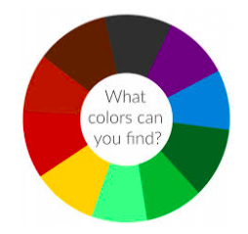

Take a walk outside and collect objects

in nature to match this color wheel. You

can also color your own wheel for the

objects you find. Just like in Dog’s Colorful

Day, go on an adventure and find colors

That match the wheel and Dog’s spots.

A blank wheel is found

in the resources section.