STEAM Things That Grow

Read Aloud
Growing Vegetable Soup
Book by Lois Ehlert

Link to Read Aloud : https://youtu.be/Vl6itu8mQ80

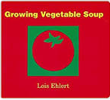

STEM VIDEO

STEM CHALLENGE: Can you draw a garden?
SONG: Five Little Pumpkins
FINE MOTOR: Cut the vegetable cards for story telling, or print two sets to play a matching
game.
OTHER: Nature Paper Dolls
Nature Art Rubbings
GROSS MOTOR: Get moving inside or outside in your yard! So get outside, safely, when you can

LESSON 6.7
Teaching Procedure:

Why and/or how question:
How can we draw a garden? What are the different parts of a plant or vegetable?

Brainstorming
Discuss what plants and vegetables need to grow.
Sun, Soil, Water, ideas from children.

Planning
Discuss and collaborate how to draw vegetables and a
garden. What do plants need?

Producing
Draw the garden.

Problem solving
Discuss how can you improve your garden. Will the plants have sunlight? Will they have air? Will they have soil for their roots?

Evaluation
Did your garden plan have all the things plants need to survive?

Prompting Thought Processes (Asks students to explain thinking)
Ask students their ideas on why they build their garden the
way that they did. Ask open-ended questions, like why or how?

GROWING VEGETABLE SOUP

STEAM Challenge:
Can you plan out and draw a vegetable garden?

Book:  Growing Vegetable Soup  Objective:  Use crayons to incorporate the different parts of a plant into a drawing.  Materials:  - Paper  - Crayons  - You can also print out the Vegetable Soup story cards to glue onto your art work. | PreK standard:  LS1-2.  Recognize that all plants and animals grow and change over time  Importance  Plants start as seeds. When a seed starts to grow we call that germination. When a plant is mature, it produces flowers. Flowers are fertilized, sometimes by animals like honeybees or sometimes by wind. After a flower is fertilized, most plants make seeds in the form of fruit. The seed inside the fruit can be planted and grow into a new plant, and the cycle starts over again.
Draw a picture of vegetable garden.

FIVE LITTLE PUMPKINS
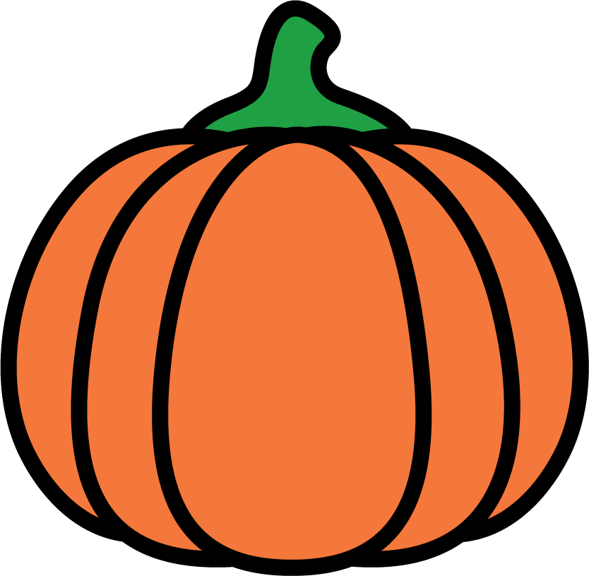
You can cut them out and glue them to a Popsicle stick,
a real stick, a cut piece of cardboard to make puppets.
This way your child can act out the song as you both sing it.

Song Lyrics:
Five little pumpkins sitting on a gate,
First one said "Oh my, it's getting late!"
Second one said "There are witches in the air,"
Third one said "but we don't care!"
Fourth one said "Let's run and run and run."
Fifth one said "I'm ready for some fun!"
Ooo ooo went the wind, and out went the lights,
And five little pumpkins rolled out of sight.

GROWING VEGETABLE SOUP CARDS
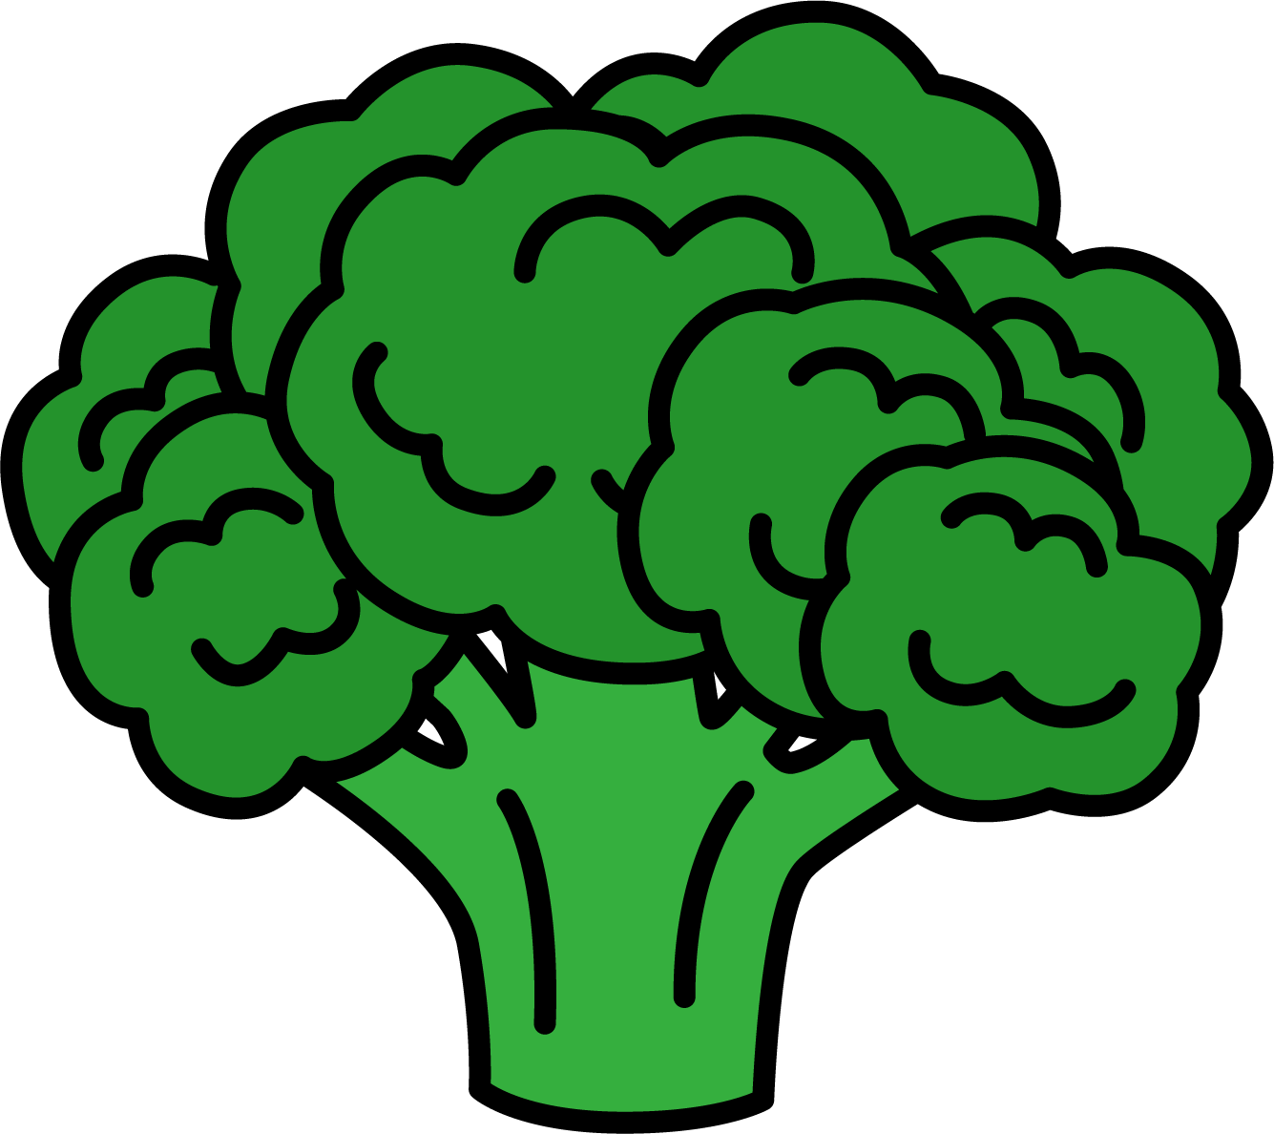  BROCCOLI | 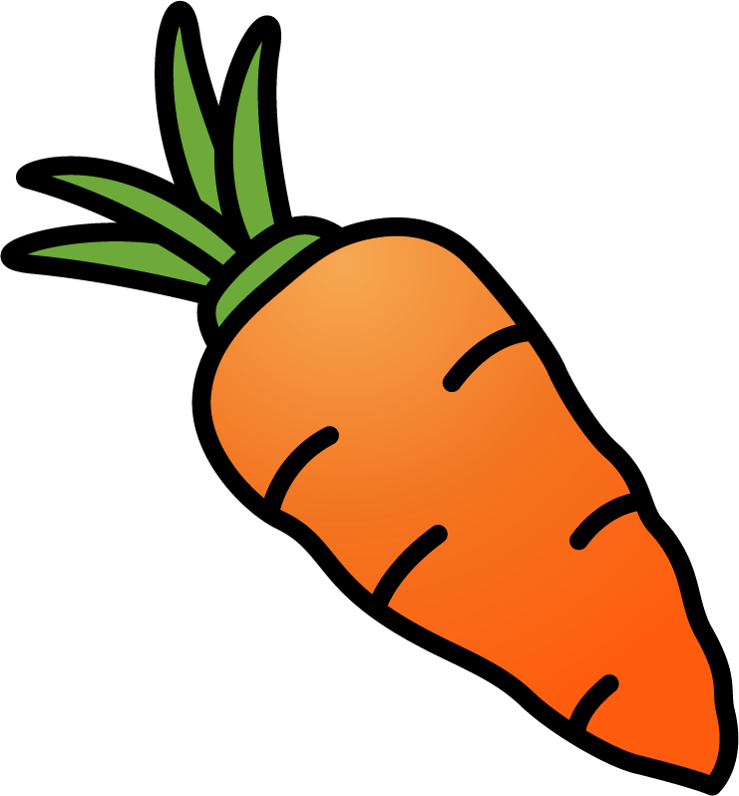  CARROT | 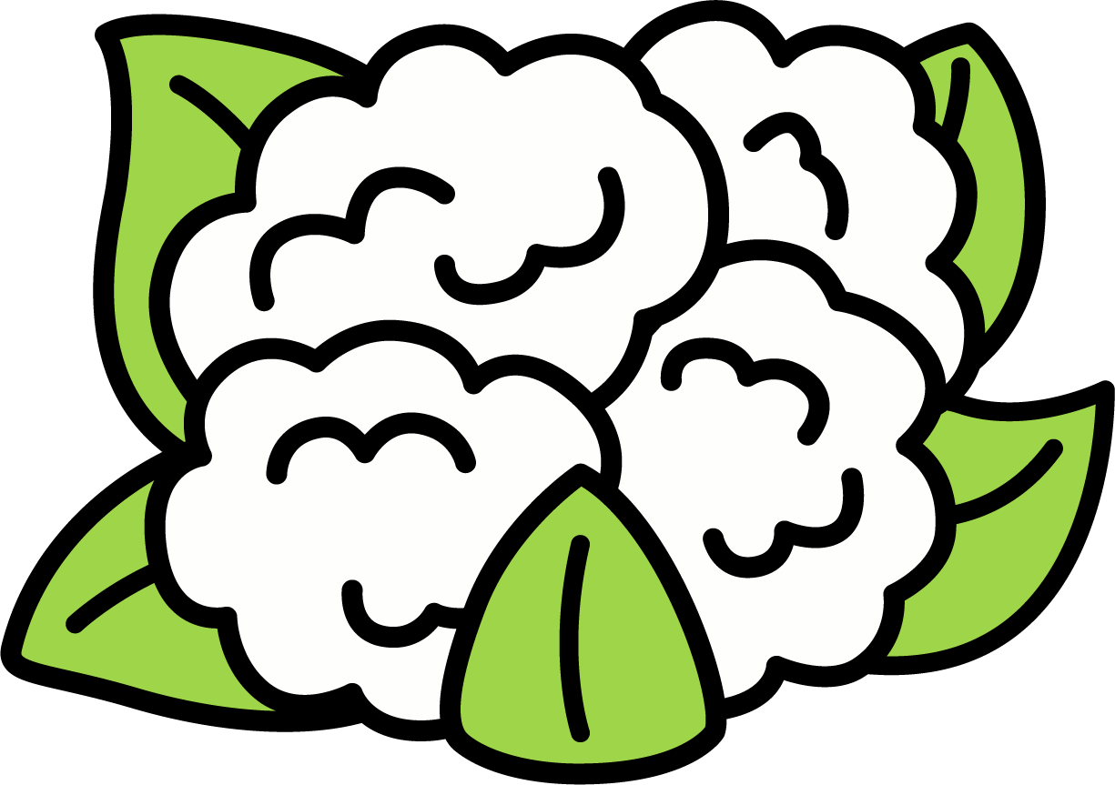  CAULIFLOWER | 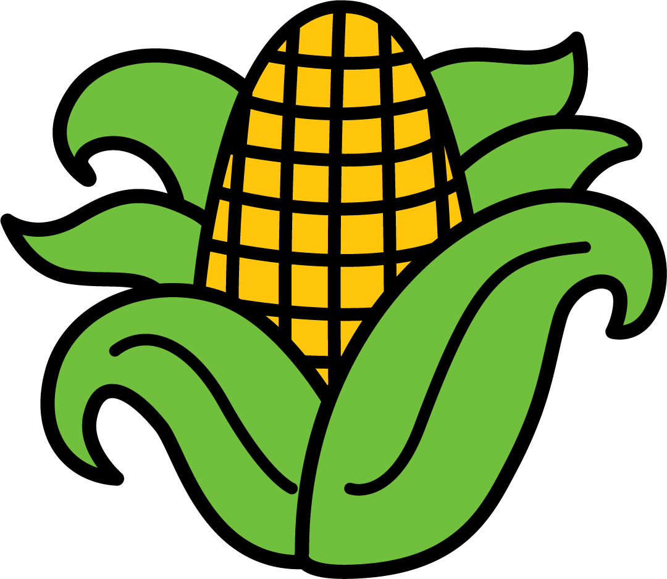  CORN
LETTUCE | 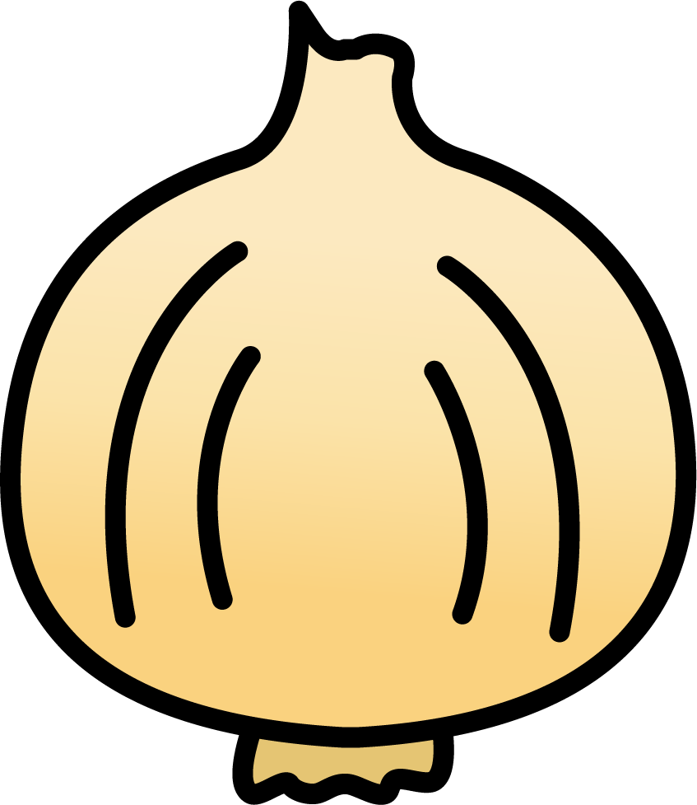  ONION | 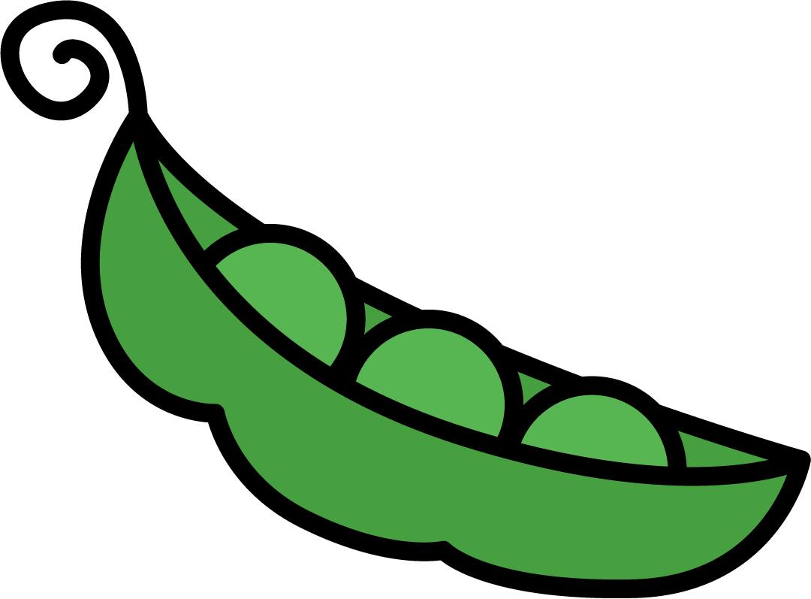  PEAS | 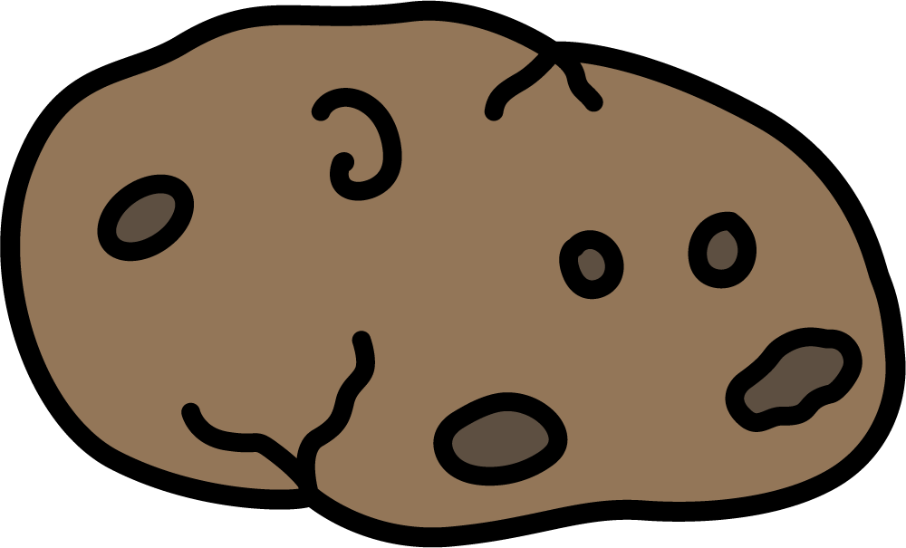  POTATOE
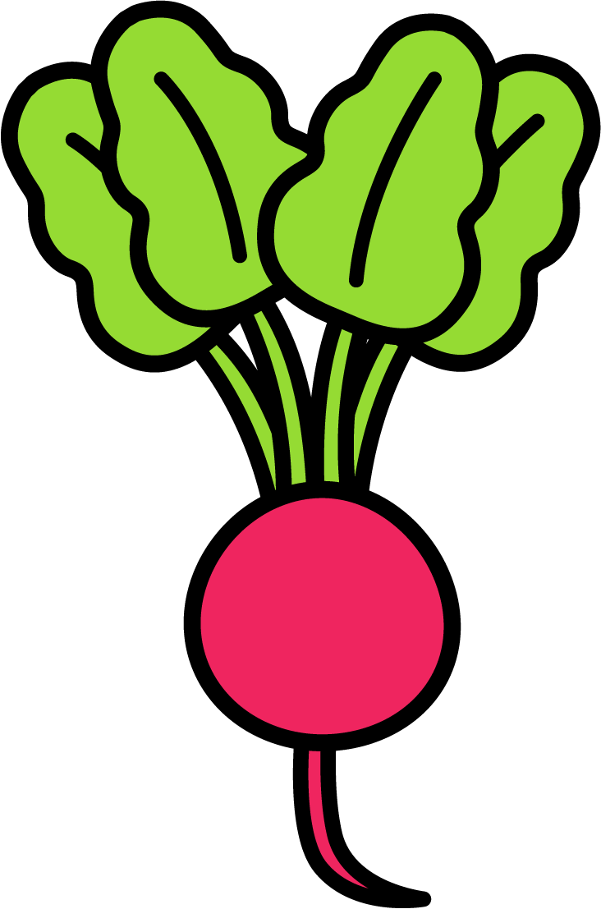  RADISH | 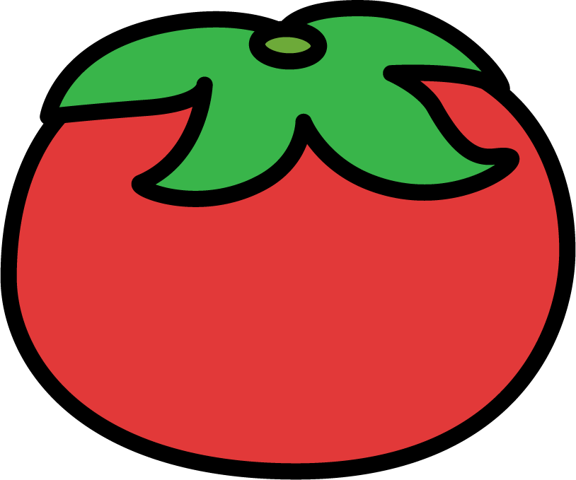  TOMATOE

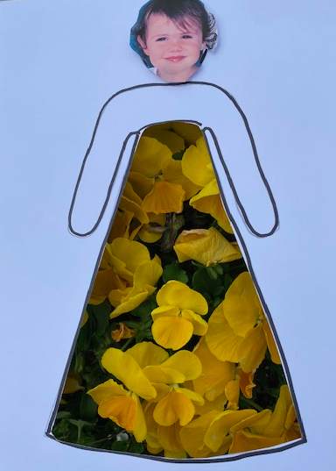
USING NATURE DOLL CARDS

Print out the Doll templates.
Print out a picture of your child’s head for the doll or color it in.
Cut out middle area
Have your child dress the paper doll in all sorts of nature textures.
Smooth
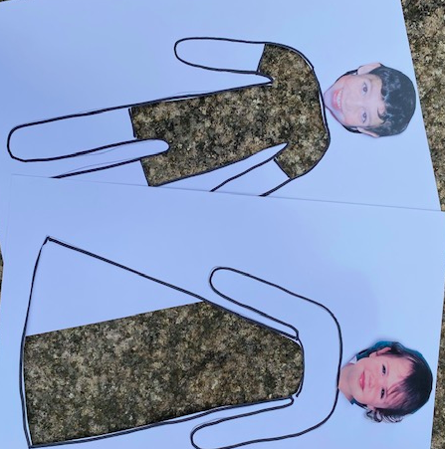
Rough
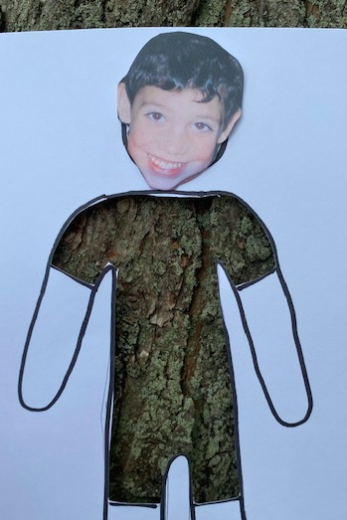
Any Natural Texture

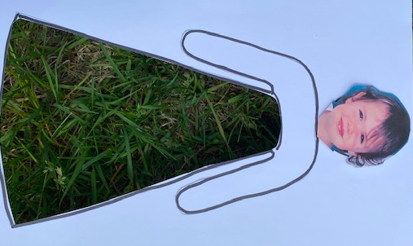

CHLOROPHYLL TREE PAINTINGS

Print out the tree template, or draw a trunk on a piece of paper.
To make the paintings:
- Collect safe green leaves & grasses. Spinach leaves provide lots of green chlorophyll while some other types of leaves don’t provide as much. Test the different types of leaves you collect.
- Fold a sheet of white paper in half.
- Place several leaves between the folded paper.
- Press firmly on the leaves between the pages and rub with a metal spoon.

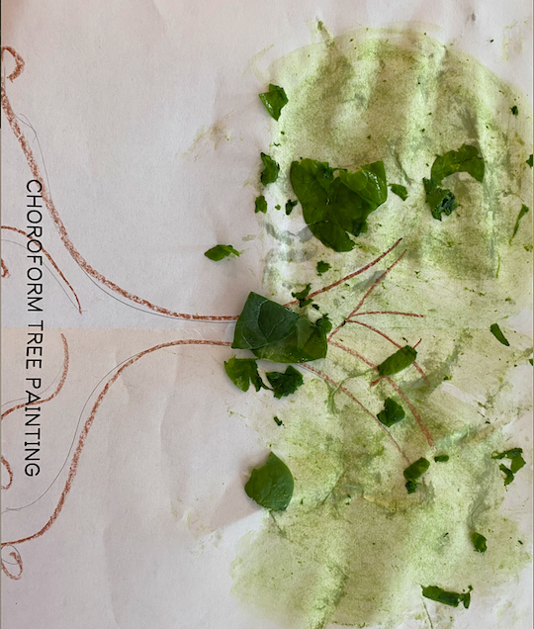
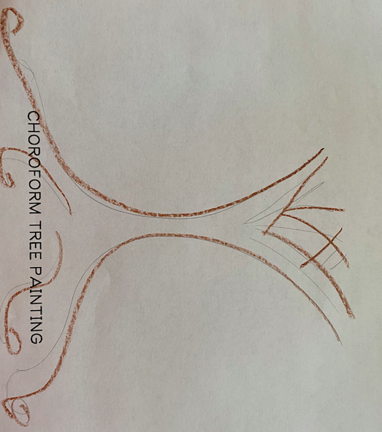
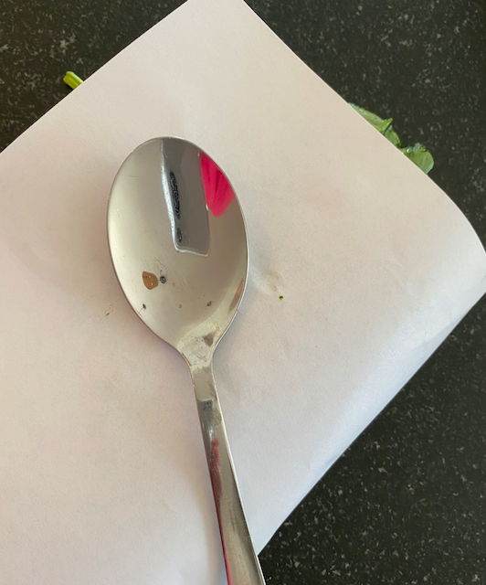
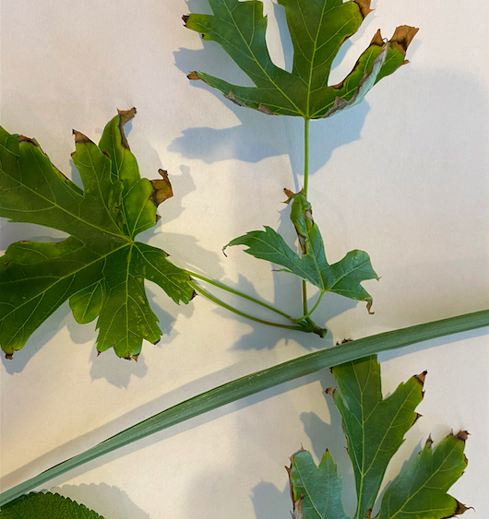

CHOROFORM TREE PAINTING

LEAF RUBBING

- Put a leaf upside down on the table.
- Place a piece of paper over the leaf.
- While holding the paper and leaf in place, use the side of a crayon to rub across the leaf. It works the best if the crayon has the wrapper off.
- Make your own rubbing plates using recycled cardboard and a glue gun to make the lines. You can also use puffy stickers or natural elements (tree trunks, rocks, the sidewalk).
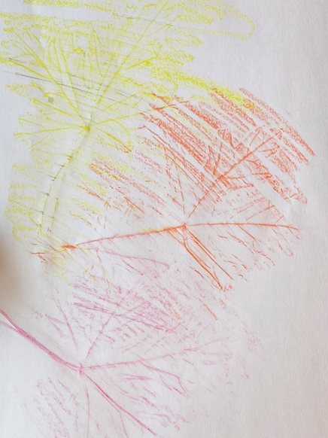
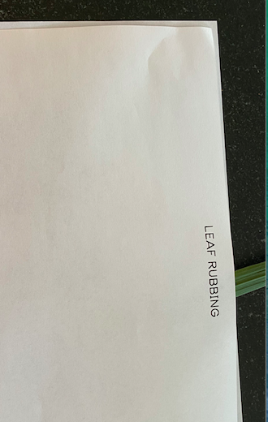

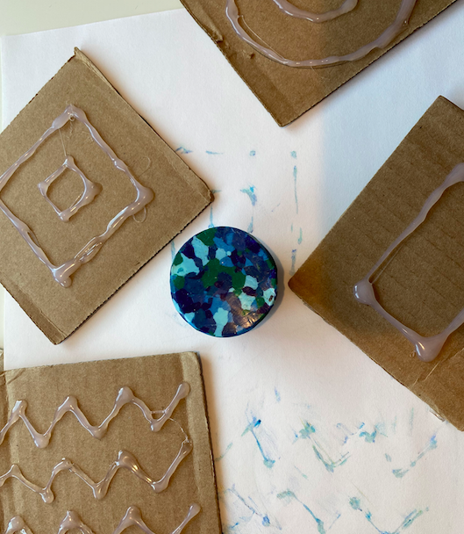
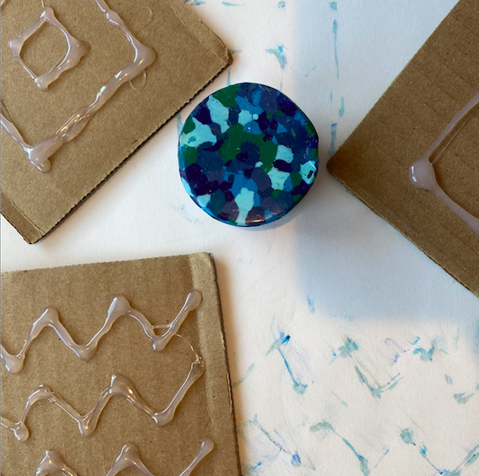

LEAF RUBBING

