STEAM World of Color
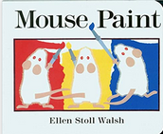
Read Aloud
Mouse Paint
Books By Ellen Stoll Walsh

Link to Read Aloud : https://www.youtube.com/embed/7n5kBBbYLHM

STEM VIDEO
STEM CHALLENGE: Can you be a color mixologist!
What colors can you make using these 3 colors (red, yellow, blue)?
SONG: WE LOVE COLOR
FINE MOTOR: Making Mice
OTHER: Watercolor Art

GROSS MOTOR: Get moving inside or outside in your yard! So get outside, safely, when you can
STORY WALK
- Gore Place has partnered with the Coordinated Family and Community Engagement (CFCE) grant-funded program administered by the Watertown public schools to re-introduce the Story Trail back to the property!
- Directions: Gore Place is located at 52 Gore Street in Waltham, Massachusetts just off Route 20. From I-90 (Mass Pike) take exit 17 to Watertown Square. Turn left onto Route 20 (Main Street). Travel 1~1/4 miles to Gore Street.

LESSON 4.6
Teaching Procedure:

Why and/or how question:
Can we make new colors by mixing 2 colors together?
Brainstorming
Red, yellow and blue are primary colors. Primary colors are colors that all other colors can be created by mixing them together. Have students brainstorm what colors will be made when mixing together yellow and blue, red and blue and red and yellow.
Planning
Discuss with the group how everyone can test their predictions.
Producing
Using one paper plate for each set of 2 colors, have the students mix the colors together (using hands or paint brushes if they are hesitant to get their hands dirty). Do one set of 2 colors at a time..
Problem solving
Discuss why yellow and blue can make different shades of green. Did the colors come out the way you thought they would? Why/why not? What happens if you mix more than 2 colors?
Evaluation
Have students complete the recording sheets for each color made
Prompting Thought Processes (Asks students to explain thinking)

What do you think would happen if you added more yellow? More blue? White?

Mouse Paint

STEAM Challenge:
Can you be a color mixologist! What colors can you make using these 3 colors (red, yellow, blue)?

Book:  Mouse Paint  Objective:  Have the students make a prediction and then mix the colors to determine if their hypothesis was correct.  Materials:  - 3 different colors of paint (either finger paint of tempera paint) – red, blue, yellow,  - Paper plates,  - Smocks  - Paintbrushes | PreK standard:  PS1-4  Recognize through investigation that physical objects and materials can change under different circumstances.  Importance  - Mixing colors promotes critical thinking and problem solving skills. The ability to understand cause and effect through observation, figure out how things work, and engage in problem solving skills by testing different ways to achieve a certain color are important early childhood skills.  - Mixing colors is just as important as the technique or style of your work. Choosing the right hues can make a huge impact in conveying the emotion of a painting; it goes hand-in-hand with the subject matter.

COLOR MIXING EXPERIMENT LESSON 4.6

WE LOVE COLOR
Tune: Head, Shoulders, Knees and Toes

Red, yellow, green and blue, green and blue
Red, yellow, green and blue, green and blue
Purple, orange brown and black
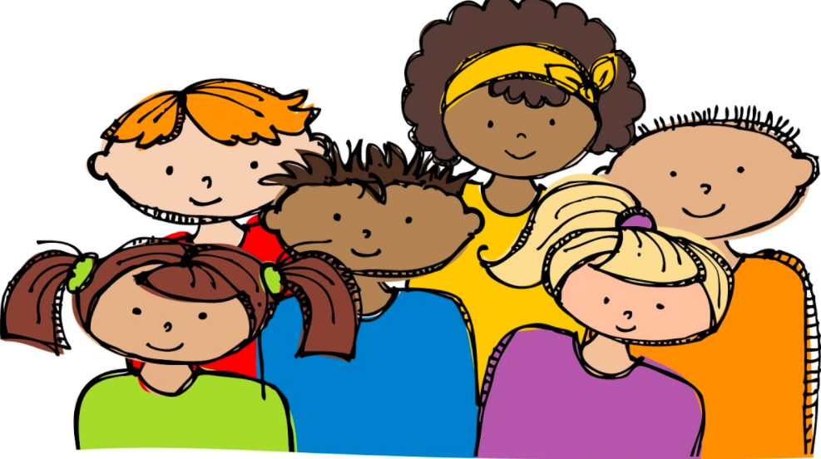
Red, yellow, green and blue, green and blue

Red, yellow, green and blue, green and blue
Red, yellow, green and blue, green and blue
Purple, orange brown and black
Red, yellow, green and blue, green and blue

Red, yellow, green and blue, green and blue
Red, yellow, green and blue, green and blue
Purple, orange brown and black
Red, yellow, green and blue, green and blue
I see the wind most everywhere!

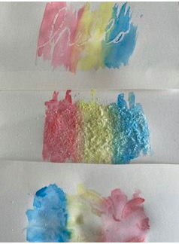
Experimenting with Water Colors

- Crayon Resist & Water Colors:
Have your kids draw a picture using white crayons first on the paper. Any white crayons will do. The next step is to paint over the white crayons. See what is revealed when you paint over it.

- Experimenting with Plastic Wrap:
Have your child paint the paper with lots of water. Then use plastic wrap to dap on the painting. Let the painting dry, then take off the plastic and see what is left.

- Crystallizing Watercolors:
Have your child paint on the paper, then throw salt on it. Let the painting dry, then brush off the salt and see what is left.

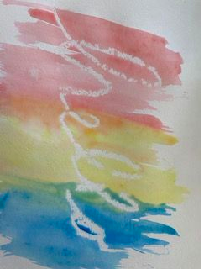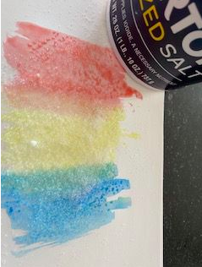

Making Mice from Mouse Paint

Materials Needed:
- blue, red, and yellow paper
- scissors
- pink cardstock cut into tiny hearts
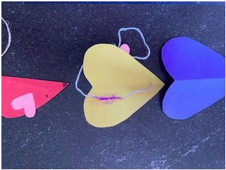
- sponges (or paintbrushes)
- tape/glue
- yarn or ribbon
- crayon to make nose

