STEAM WIND & WATER

Read Aloud
No, David!
Book by David Shannon

Link to Read Aloud :
https://www.youtube.com/watch?v=ti-D2iLRIrk&feature=youtu.be

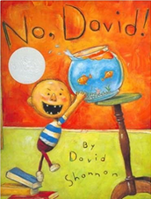

STEM VIDEO
STEM CHALLENGE: Can you use your five senses to identify objects?
SONG: I see the wind
FINE MOTOR: Make a paper bag puppet of David
OTHER: 5 Rules - Story Recall
GROSS MOTOR: Get moving inside or outside in your yard! So get outside, safely, when you can

LESSON 4.5
Teaching Procedure:

Why and/or how question:
How can we identify objects with our five senses?
Brainstorming
Give students an opportunity to examine all objects. Children
can describe items by various attributes.
Planning
Discuss what senses you could use or need to identify each object.
Producing
Hide behind partition or place item individually into Mystery Box. Each child will use their senses to identify each object. If children need support you can offer ‘clues’ about each object.
Problem solving
Discuss challenges in identifying certain objects with certain senses.
Evaluation
Did you identify each object with your senses?.

Prompting Thought Processes (Asks students to explain thinking)

Did/ could you use each of your senses to identify each object? Why or why not? Was it difficult to do?
Each child can draw each object on their recording page in the appropriate sense or senses column(s) used to identify the object. Alternatively, have pictures of each object for children to glue onto recording page.

No David

STEAM Challenge:

Can you use your five senses to identify objects?

Book:  No David  Objective:  Students will use their five senses  to identify various objects.  Materials:  - Various items that can be  identified by each sense  (ex. leaf- touch; cinnamon  or powdered donut- smell;  orange/ persimmon- taste;  whistle- sound; crayon-  sight)  - Clues for each object to  identify  - Mystery Box, partition, or recycled tissue box works really well.  - Recording sheet for each  Child. | PreK standard:  LS1-3:  Use their five senses in their exploration and play to gather information.  Importance  - Supports children’s use of multiple methods of investigation and  observational skills.  - Improves use of senses to gather information.  - Enhances logical thinking capability
Sort by one of the five senses. LESSON 4.5

SIGHT | SMELL  Sort by one of the five senses. | SOUND | TASTE | TOUCH

I SEE THE WIND
Sung to: "Hush Little Baby"
I see the wind when the leaves dance by.
I see the wind when the clothes wave "Hi!"
I see the wind when the trees bend low.
I see the wind when the flags all blow.
I see the wind when the kites fly high.
I see the wind when the clouds float by.
I see the wind when it blows my hair.
I see the wind most everywhere!

MAKE A PAPER BAG PUPPET OF DAVID

- First, you will need to print out the No, David Puppet sheet
- Review or teach your child to use the scissors. Scissors are sharp tools, please be safe.
- Once the three pieces are cut out your child can glue them to the paper bag.
- Turn it over and you have a brown paper bag No, David Puppet.

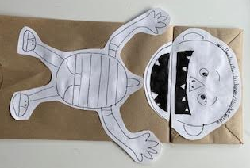
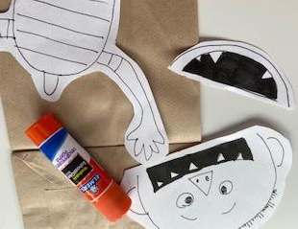
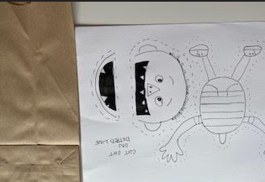

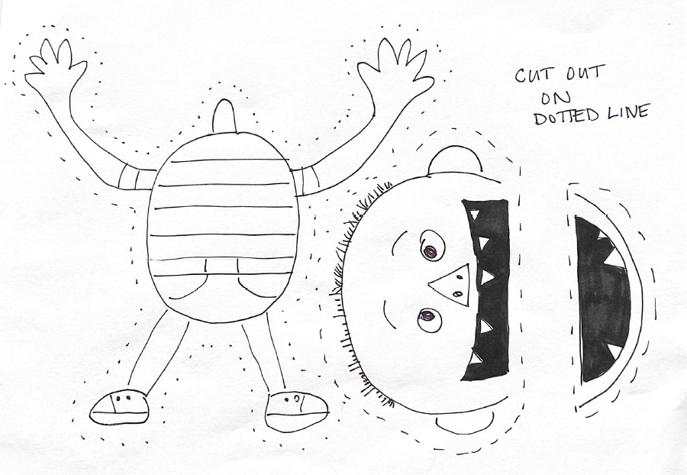
Can you cut and paste 5 rules that you learned with David?

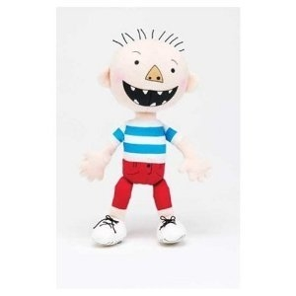
YES,
David!

NO,
David!

1. 1.

2. 2.

3. 3.

4. 4.

5. 5.
