STEAM World of Color
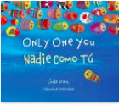
Read Aloud
Only One You
Book by Linda Kranz

Link to Read Aloud : https://www.youtube.com/embed/KXUNDjUuH84

STEM VIDEO
STEM CHALLENGE: Can you create a picture of you and someone in your family?
Can you compare similarities and differences between family members what looks the
same what looks different?
SONG: WE LOVE COLOR
FINE MOTOR: MAKE A RAINBOW RIBBON STREAMER RING
OTHER: Match Game and Puzzle

GROSS MOTOR: Get moving inside or outside in your yard! So get outside, safely, when you can
STORY WALK
- Gore Place has partnered with the Coordinated Family and Community Engagement (CFCE) grant-funded program administered by the Watertown public schools to re-introduce the Story Trail back to the property!
- Directions: Gore Place is located at 52 Gore Street in Waltham, Massachusetts just off Route 20. From I-90 (Mass Pike) take exit 17 to Watertown Square. Turn left onto Route 20 (Main Street). Travel 1~1/4 miles to Gore Street.

LESSON 1.2
Teaching Procedure:
Why and/or how question:
Who do you look like? How can you tell? (use baby animals if you have children who are adopted in your class!)
Brainstorming
What are some ways we look like people in our family…hair color, eye color, skin color? How can you tell a baby animal and mom match? Do babies and their parents have to look alike?
Planning
Discuss some ways you look like people in your family (or baby animal comparison if you have an child who is adopted) - draw what your people (or animals) might look like.
Producing
Create/build pictures of you and someone in your family using the materials provided.
Problem solving
How can you figure out what is the same and what is different? Have the board maker sheet available to use.
Evaluation
What do you notice about the 2 creations? What things are the same? What is different?

Prompting Thought Processes (Asks students to explain thinking)
What do you notice about the picture you drew? What things are the same? What is different?

Oonga Boonga

STEAM Challenge:

Can you create a picture of you and someone in your family? Can you compare similarities and differences between family members what looks the same what looks different?
Book:  Noisy Nora  Objective:  Explore features of yourself and your parents so that you can observe similarities and differences. What looks the same, and what looks different.  Materials:  - family photos  (sent in to school prior to activity)  - mirrors  - crayons  - paper  - (Be sensitive to kids who don’t live with biological parents.) | PreK standard:  LS3-1  Use observations to explain that young plants and animals are like but not exactly like their parents  Importance  Inherited Traits  Most babies are not exact copies of their parents, which means they have some differences, however slight. This conversation can begin at the earliest elementary levels with conversations about the fact that children do not look exactly like their parents or that the new kittens in the house don’t look like their mom or dad.

Draw a picture of you and a family member. LESSON 1.2

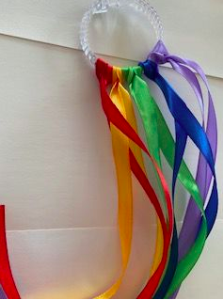
The Color Song

Tune: If you’re Happy
and You Know It

If your clothes have any red, any red
If your clothes have any red, any red
If your clothes have any red, put your hand on your head
If your clothes have any red, any red

Repeat but change the color
Blue – Put a finger on your shoe
Brown – Touch your hand to your crown (head)
Black – Touch your hand to your back
Green – Put Your hands on your knees in between

MAKE A RAINBOW RIBBON STREAMER RING:

Materials:
- Ribbon in rainbow colors: red, orange, yellow, green, blue, purple
- scissors
- a ring: This one pictured is from the dollar store and it is a shower curtain ring

Instructions:
- Take your first color (red) and fold it in half.
- Loop it through the ring, and then pull the ends of the ribbon through the loop.
- Pull through to the outside of the ring.
- Then do the same thing for the other colors.

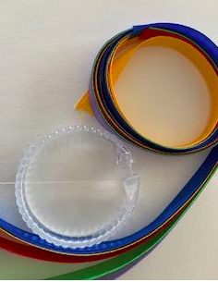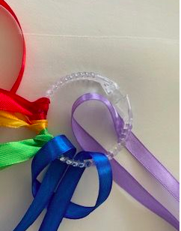

Match Game & Puzzle
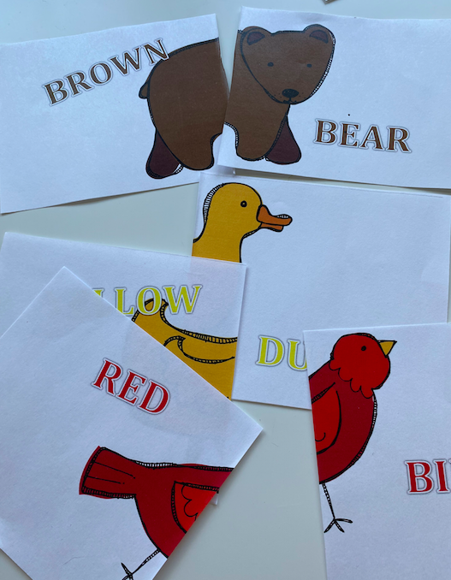
Print the Brown Bear Puzzle Sheets in resources. If you can’t print it, you can make it by drawing the character on paper, you can cut a magazine picture into two parts. Be creative.
Help your child(ren)
Try to put it back together in order.
Easy: Cut in two pieces
Medium: Cut into five pieces
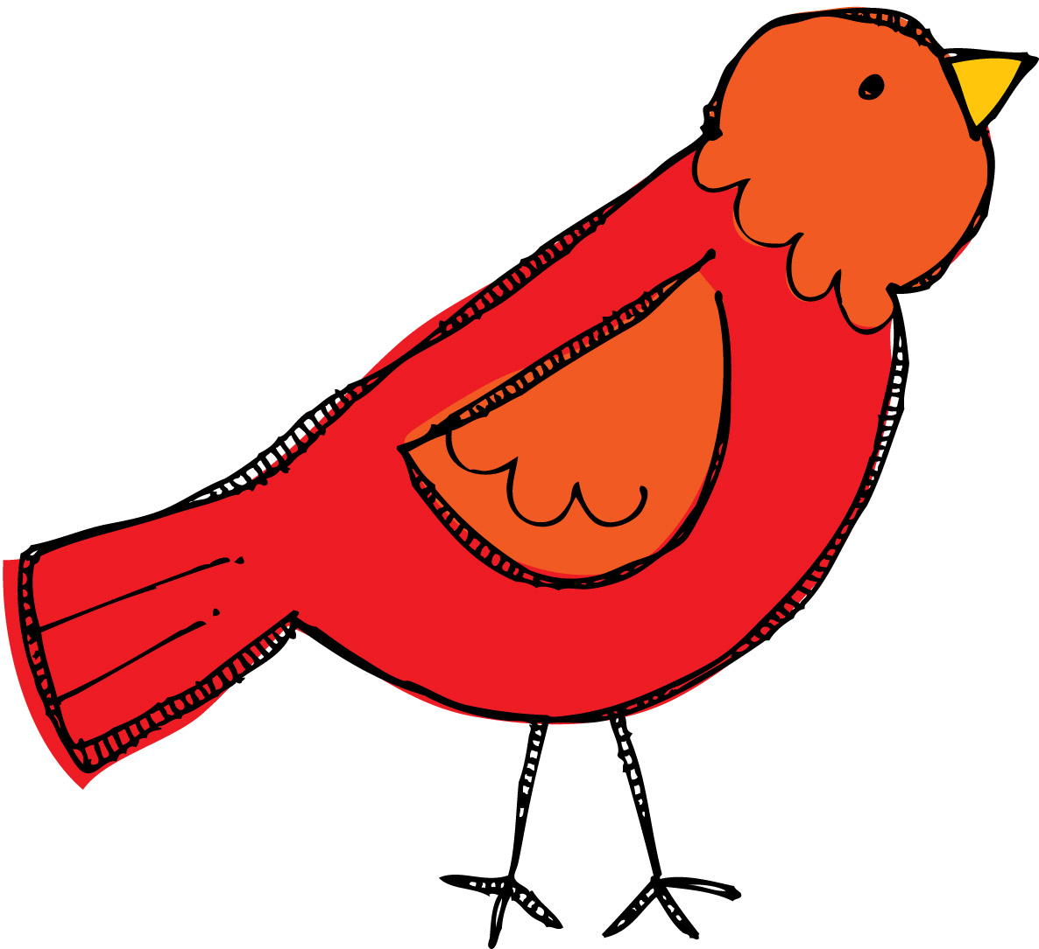
Hard: Cut into 10 small pieces

