STEAM WIND & WATER

Read Aloud
It Looked like Spilt Milk
Book by Charles Green Shaw

Link to Read Aloud : https://www.youtube.com/embed/O5oBybVHVbI

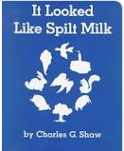

STEM VIDEO
STEM CHALLENGE: Can you make a substance that can be both a liquid and a solid?
SONG: I see the wind
FINE MOTOR: Make cloud shapes
OTHER: Cloud Painting
Make a Windsock
GROSS MOTOR: Get moving inside or outside in your yard! So get outside, safely, when you can

LESSON 3.6
Teaching Procedure:

Why and/or how question:
How can we identify if something is a liquid or a solid?
Brainstorming
What do you think it will look like when you mix the ingredients together?
Planning
Discuss how it will look and feel
Producing
Combine the ingredients and move them around.
Problem solving
??
Evaluation
Did it come out the way you expected?

Prompting Thought Processes (Asks students to explain thinking)

Did it come out the way you expected? Did you make a solid? Did you see it in the liquid state? Ooblek is a suspension. It is hold properties of both liquids and solids.

It Looked like Spilt Milk

STEAM Challenge:

Can you make a substance that can be both a liquid and a solid?

Book:  Dear Juno  Objective:  Students will observe liquids and solids and how they interact  Materials:  - 1 cups water  - 2 cups cornstarch  - Small amount of food coloring (optional) | PreK standard:  PS 1-1  Raise questions and investigate the difference between liquids and solids and develop awareness that a liquid can become a solid and vice versa - ooblek  Importance  - Oobleck can teach children scientific skills of observation and prediction. It is also a fantastic way to introduce children to basic concepts of matter..  - In addition to learning about science concepts, Oobleck is also great for the development of fine motor skills as children work and strengthen their little hand muscles while engaged in sensory play.
Oobleck Experiment LESSON 3.6
OBJECT | PREDICTION | RESULT
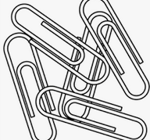 | Sink  or  Float | Sink  or  Float
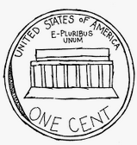 | Sink  or  Float | Sink  or  Float
Pick an item to test | Sink  or  Float | Sink  or  Float
Pick an item to test | Sink  or  Float | Sink  or  Float
Pick an item to test | Sink  or  Float | Sink  or  Float

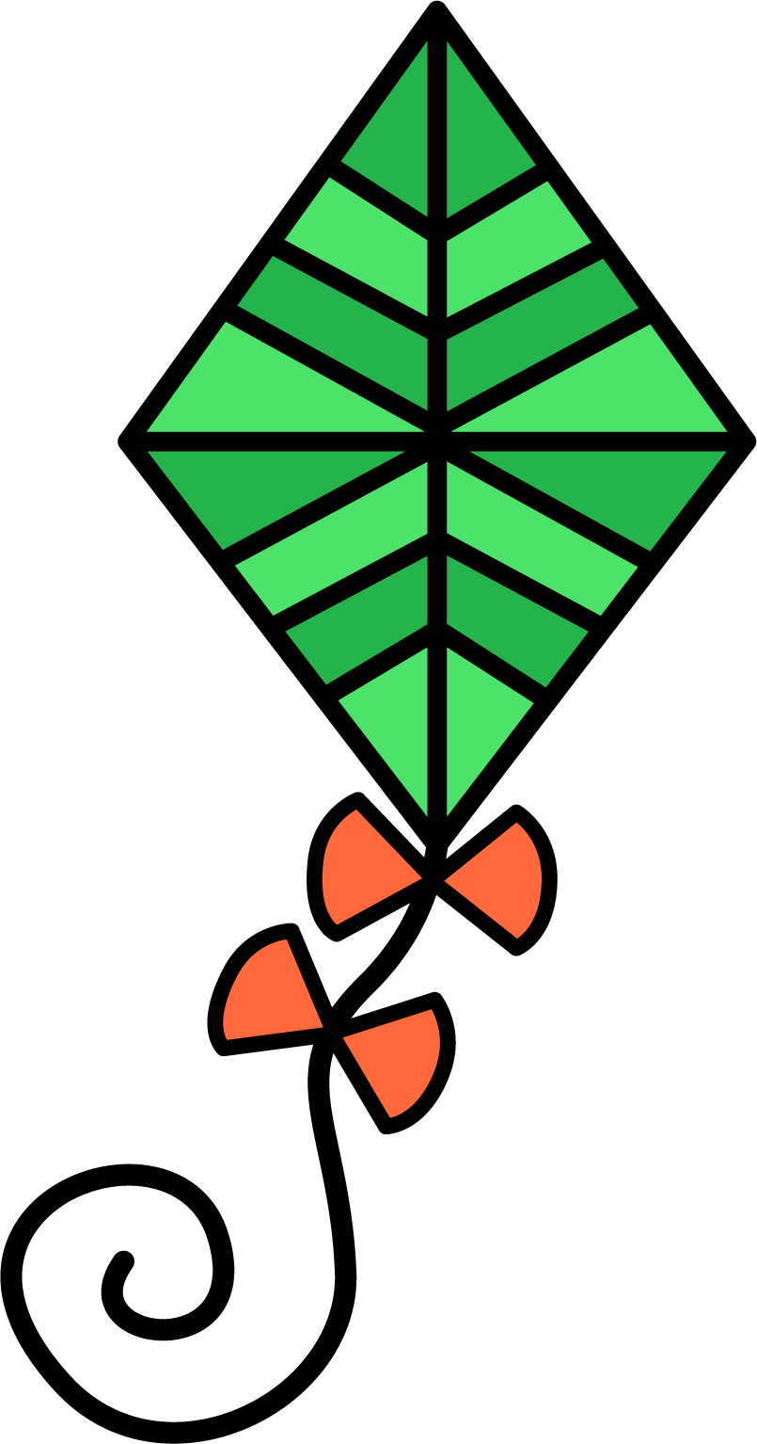
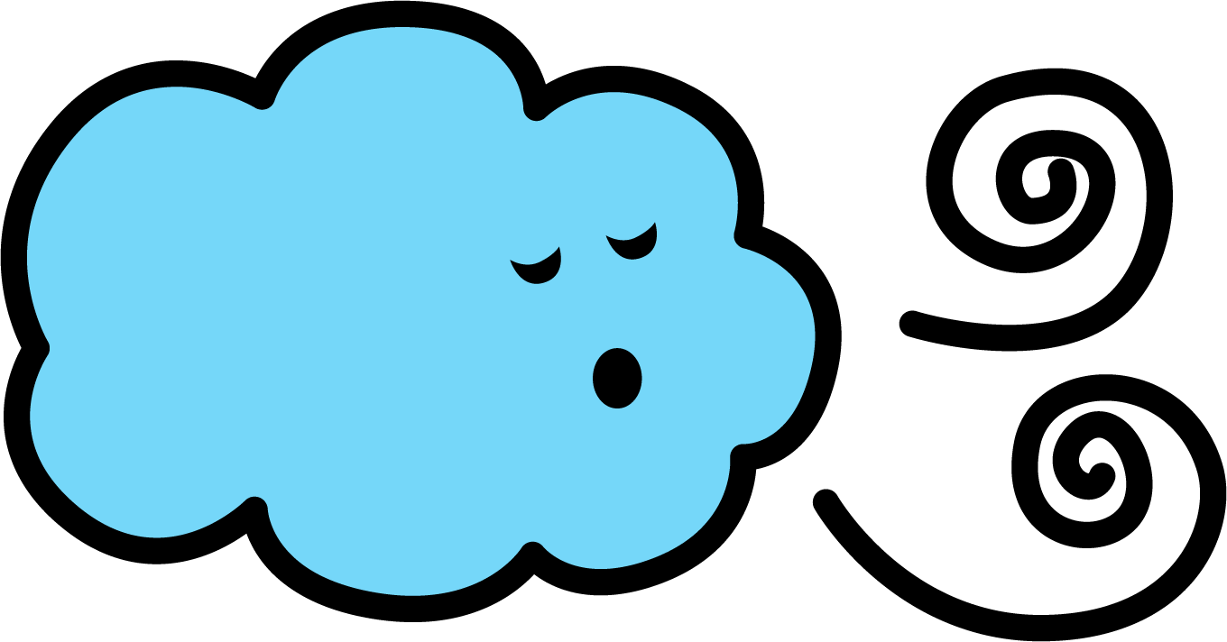
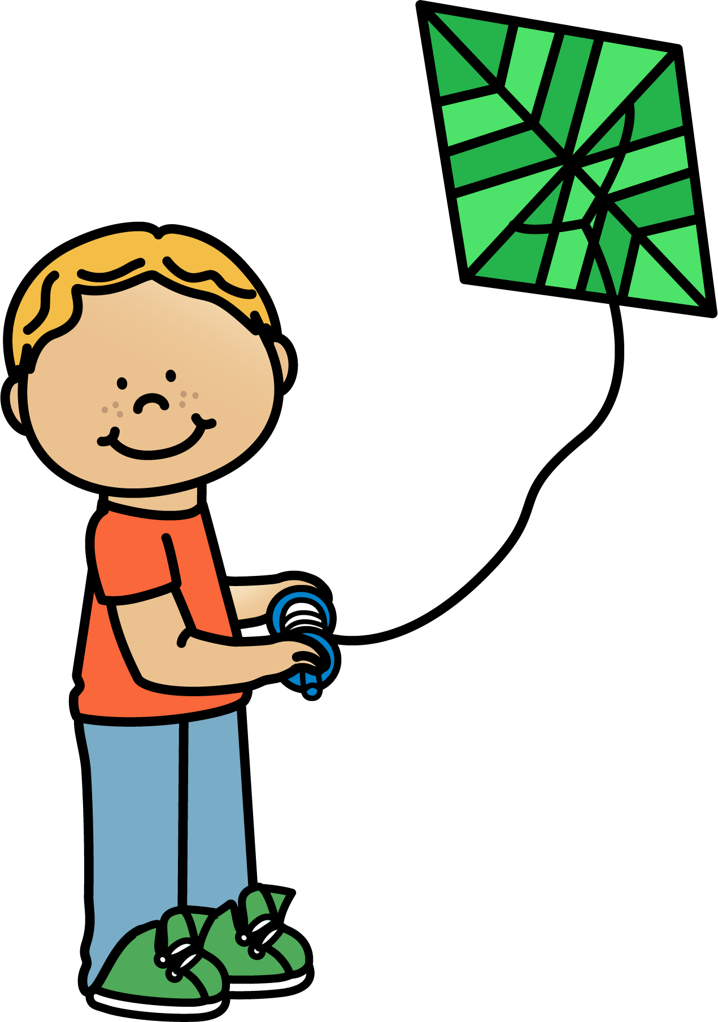

I SEE THE WIND
Sung to: "Hush Little Baby"
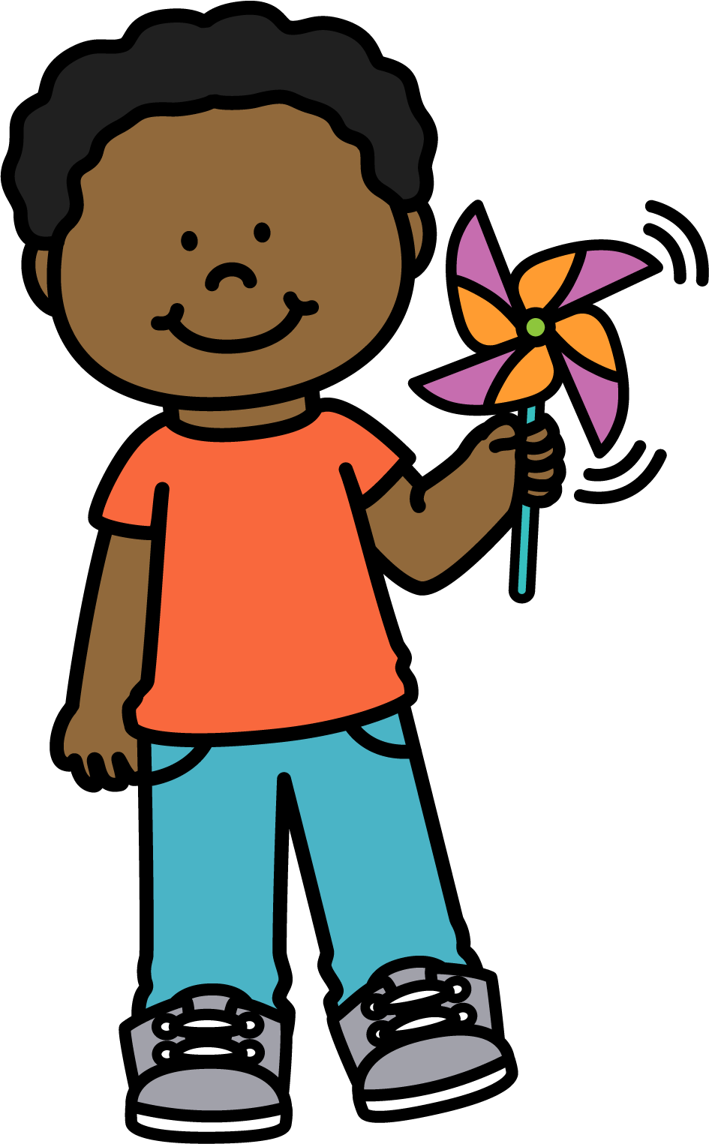
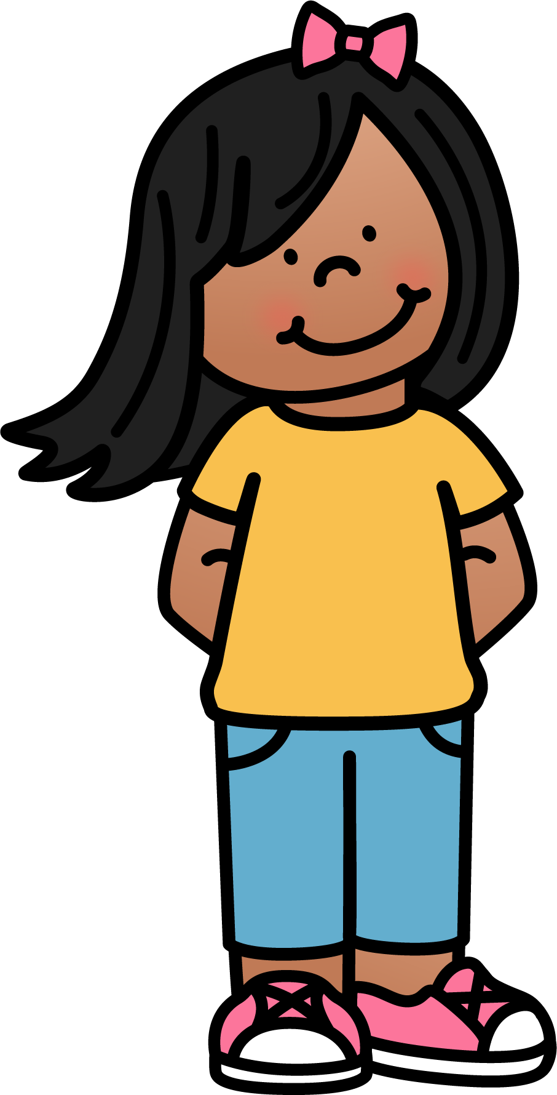
I see the wind when the leaves dance by.
I see the wind when the clothes wave "Hi!"
I see the wind when the trees bend low.
I see the wind when the flags all blow.
I see the wind when the kites fly high.
I see the wind when the clouds float by.
I see the wind when it blows my hair.
I see the wind most everywhere!

MAKE CLOUD SHAPES
Stretch and then glue the cotton balls into the shapes
Square Triangle Heart

Circle Pentagon Rectangle
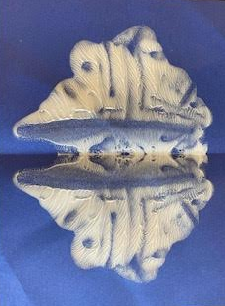
CLOUD PAINTING
Make some "cloud paint"
- Put blobs of paint on one side of the paper and folded it in half.
- You’re done. Both sides will be symmetrically
- You can also use the extra blue paint to just paint the clouds in the sky.

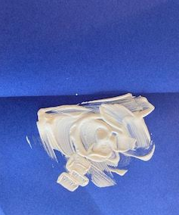

WINDSOCK CRAFT
Materials Needed for the Clouds and Rain Weather Windsock Craft:
- Blue construction paper & Recycled paper tube
- Cotton balls
- Yarn, ribbon, jute cord
- glue or tape
- First, you will need to make the clouds. Do this by pulling and spreading the cotton balls (great fine motor activity) and gluing them to a blue piece of construction paper.
- Next, make some small holes in the blue paper for the yarn to go through before you put it on your tube. Then have your child roll the paper into a tube and use tape to secure
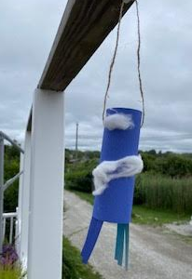
- String the yarn trough the holes and help your child tie them.
- You are ready to hang your windsock and watch the power of the wind move objects.

